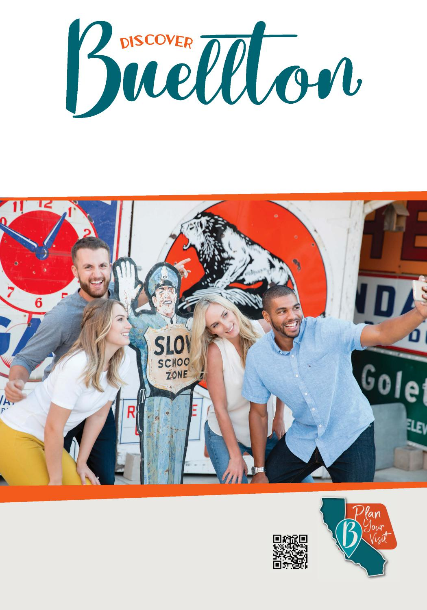
Sometimes all you need is to escape the ordinary.
#SkipTheBigCities
Download the app and start planning your adventure today.
WWW.DISCOVERBUELLTON.COM

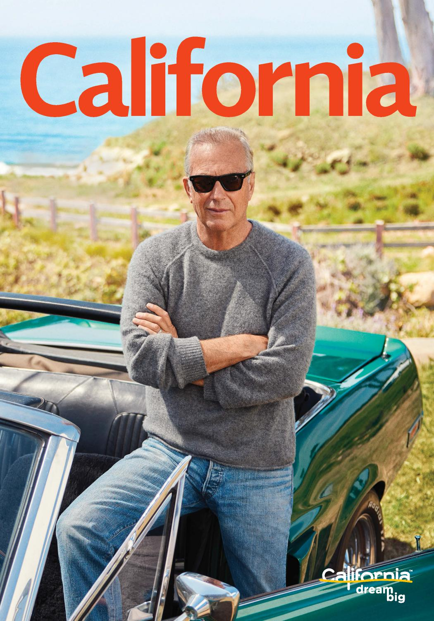
FROM SOCAL TO THE SHASTA CASCADE—9 DREAM DRIVES
VISITCALIFORNIA.COM
ROAD TRIPS
Kevin Costner
OPENS UP ABOUT HIS LOVE FOR THE OPEN ROAD

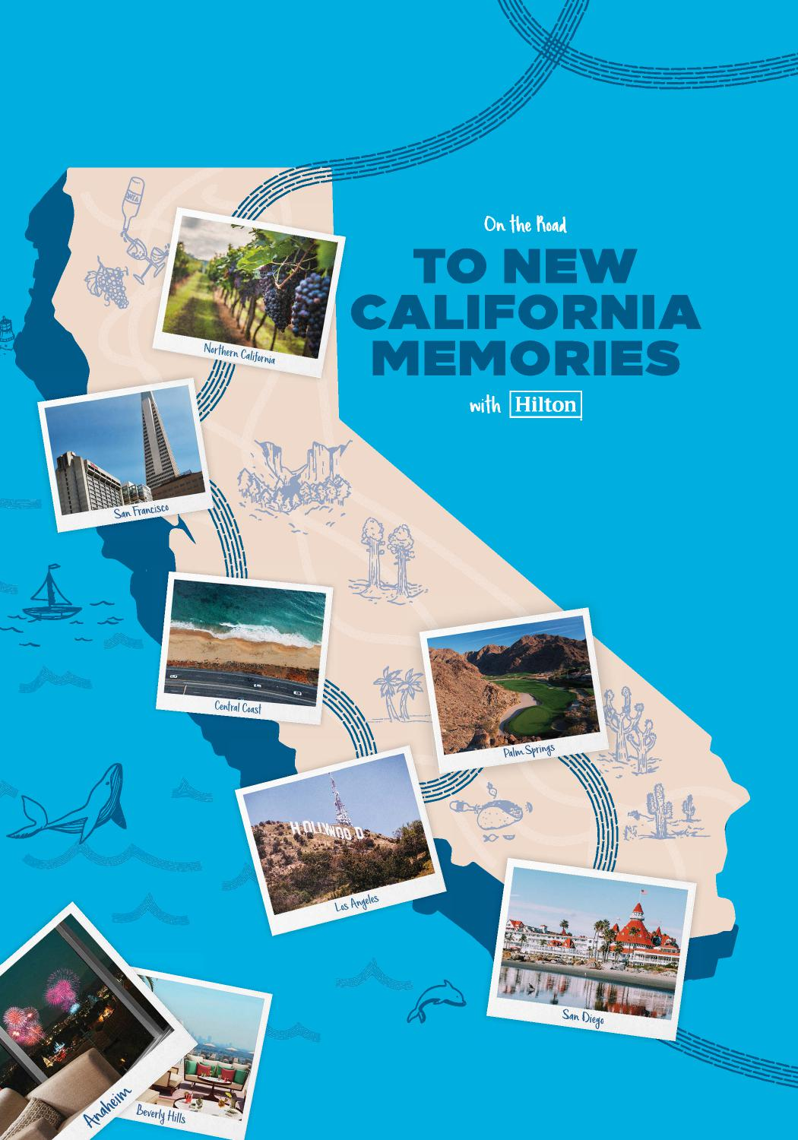
On the Nail
ALIFORNIA
MEM IES
Hilton
So" Vrfose sco
Central Coas

,IoLtr California hoad Trip

Take to the open road this summer and explore California,
making new memories at every stop along the way.
• | Hilton

Northern California
Cheers to road trip memories
Toast to your first stop at a hillside vineyard in this premier wine region.
San. Francisco
Stroll the City by the Bay
Get your steps in by seeing the ty on foot-bonus points for Lombard Street.

WHERE TO STAY: oubleTree by Hilton Hotel onoma ine ountry for a rest between wineries.
eeps
strict
WHERE TO STAY:
Hilton San Francisco Financial Bay and Alcatraz in view.

Central Coast  Dip your toes in the sand | Los Angeles  See the stars
Take your pick of 7 beaches on WHAT TO DO• heck out iconic movie
your way down the coast. locations and equally iconic L.A. cuisine.
- - • mbassy Suites by Hilton Hampton Inn & Suites
andalay Beach Hotel & Resort for ocean views Los Angeles/Hollywood to be in the middle
and occasional dolphin sightings. of Hollywood's best sights.
Palm. Sri,
Make some magic Tee off in a desert oasis
xplore all of Anaheim's legendar)M=rtkolf, of course. More than 100
WHAT TO DO:
theme parks, great for kids of all ages. courses. Fore!
- • ilton Anaheim for fireworks La Quinta Resort & Club,
ight outside your window. A Waldorf Astoria Resort to play and stay like
a champion.

San Diet
Bask in endless summer vibes
Hang onto summer with sun, surf and spectacular sunset views.
i.Iy.Iy.⁻L⁻i NE Hotel del Coronado, Curio Collection by Hilton to experience a California icon.
••••••••
Start lour _{l}ourne3. at
Travel.Hilton.com/California
Book your California stays and download the Hilton Honors app before you go for easy, breezy check-in with Contactless Arrival.

18 26 38
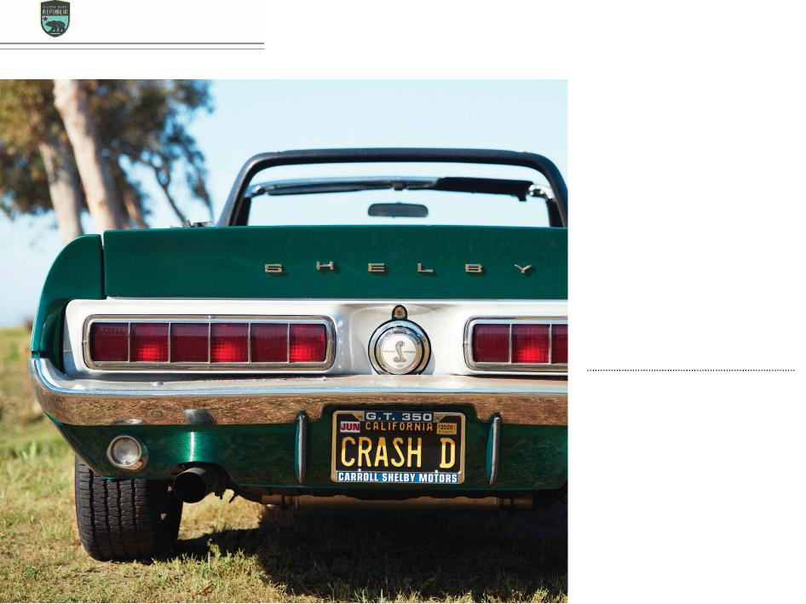
ROAD TRIPS 2021
In This Issue
FOLLOW THESE TIPS AND EXPLORE NINE EXCITING CALIFORNIA DESTINATIONS
8 Rent the Perfect Vehicle Here’s how to match your journey with the right set of wheels
10 Going Mobile
Kevin Costner wants to narrate your next road trip
46 Pet-Friendly Road Trips Tips and tricks for traveling with your favorite furry companion

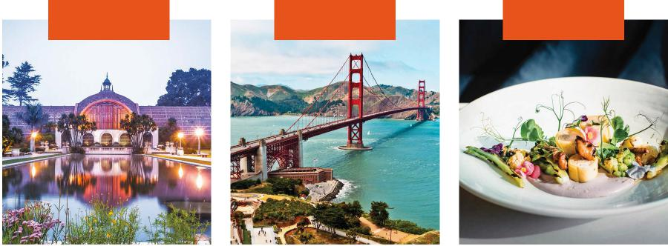
SOUTHERN CALIFORNIA
NORTHERN CALIFORNIA
SACRAMENTO & BEYOND

20 San Diego Sojourn Breathtaking ocean views meet vibrant towns and a wild desert
22 SoCal Trifecta
An adventure to coastal cities, an alpine playground, and the sun-drenched desert
24 Central Coast Escape Discover sun-splashed beaches, whitewashed missions, and an iconic castle
28 Golden Gate to Big Trees Explore redwoods and more along Northern California’s pristine coastline
30 Bounty & Beauty
Travel through the fertile Central Valley en route to experiencing three amazing parks
34 Spectacular Highway 1 Drive America’s most famous cliff-hugging highway
40 Foothills to Tahoe
Discover enchanting
Gold Rush towns and North America’s largest alpine lake
CLOCKWISE FROM TOP: AMANDA FRIEDMAN; SORAYA MAT OS; STEVE PROEHL/GETTY IMAGES; LOOP IMAGES/GETTY IMAGES
42 Northern Grandeur Adventure Ramble past a cinematic landscape of wonders in “UpState California”
44 Wine to Waterfalls
An epic wine-tasting expedition leads to Yosemite National Park’s scenery-filled wonderland

2 | VISITCALIFORNIA.COM

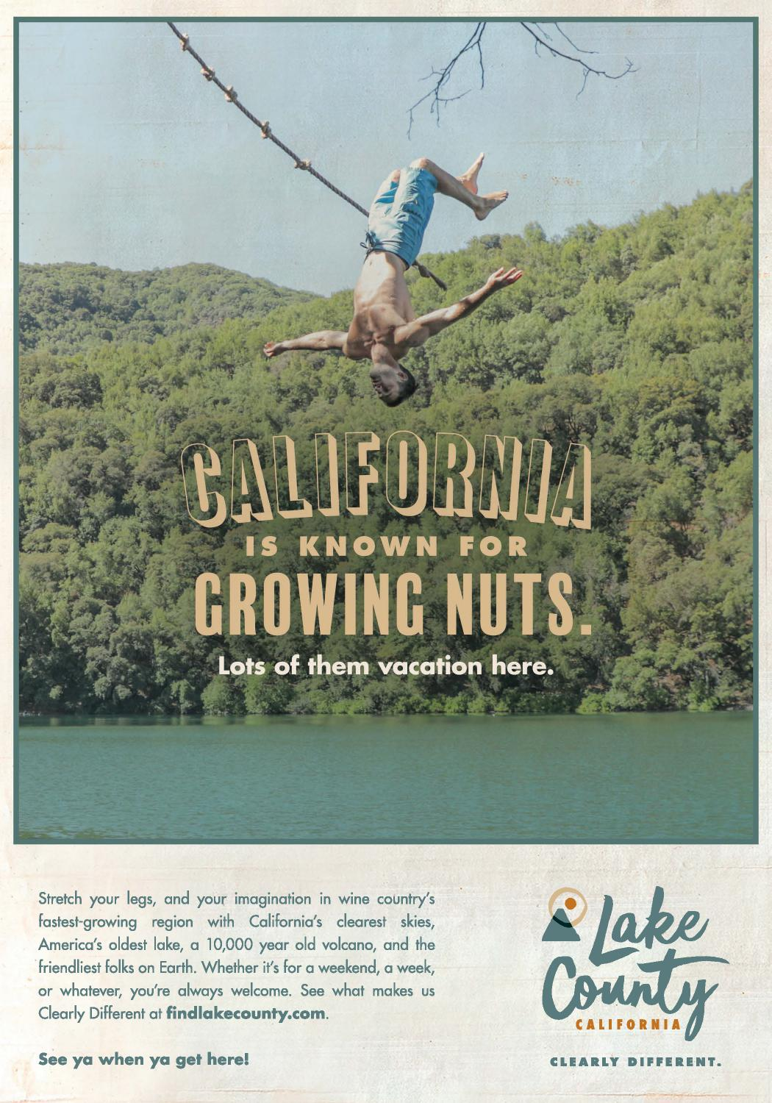
®

STATE OF CALIFORNIA GAVIN NEWSOM, GOVERNOR
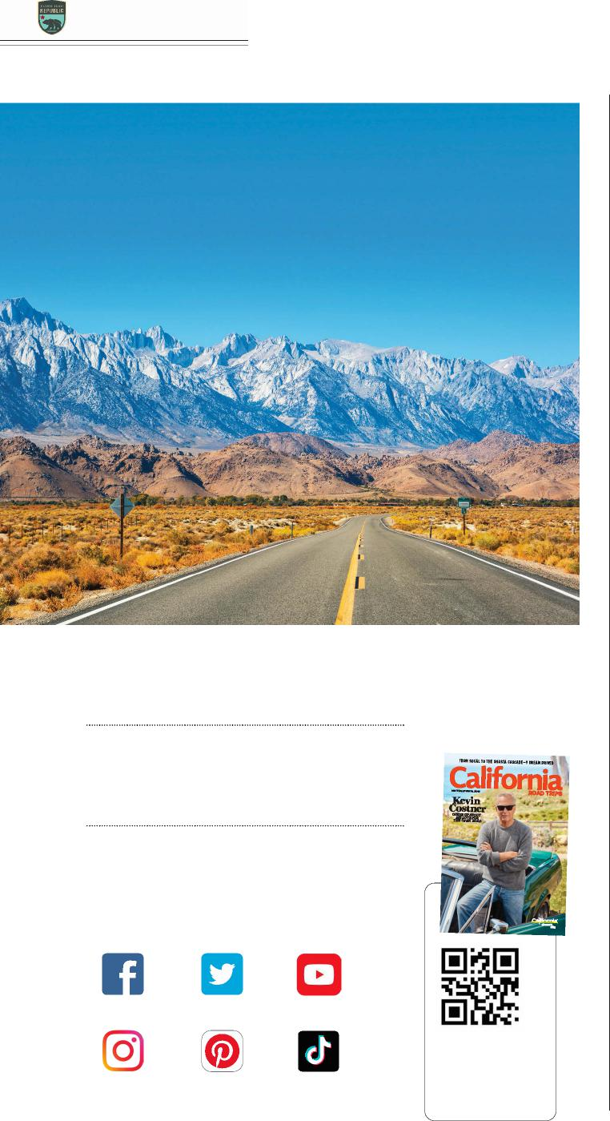
ROAD TRIPS 2021
50+ DREAM DRIVES
Plan your next adventure on the California Road Trip Republic hub. Home to more than 50 itineraries, you’ll find incredible trips that take you up and down iconic Highway 395 in the Eastern Sierra, with breathtaking stops in Mono and Inyo counties. Discover what this region, and the entire state, has to offer. visitcalifornia.com/roadtrips
Listen
CALIFORNIA NOW PODCAST
Our guests, including Kevin Costner, discuss their
Golden State favorites. visitcalifornia.com/podcasts
@VisitCalifornia
@VisitCalifornia
Follow
SOCIAL CHANNELS
Find us on social media to get instant inspiration
for your next getaway.
Sign Up
E-NEWSLETTER
Get your dose of weekly wanderlust, delivered straight to your inbox. visitcalifornia.com/newsletters
@VisitCalifornia @VisitCalifornia
@VisitCA @VisitCA
Hold your phone’s camera over this smart code for a digital version of this guide.
VISIT CALIFORNIA
President & Chief Executive Officer
Caroline Beteta
Vice President of Marketing
Lynn Carpenter
Director of Consumer Content
Gwynne Spann
Digital & Printed Publications Manager
Kayla Bell
Content Coordinator
Lucas Himovitz
Visit California
555 Capitol Mall, Suite 1100, Sacramento, CA 95814 916/444-4429; fax: 916/444-0410 visitcalifornia.com
California Road Trips is published by Meredith Travel Marketing for Visit California. © 2021 Visit California. ALL RIGHTS RESERVED. Printed in the USA.
MEREDITH TRAVEL MARKETING Editorial
Editor & Creative Director John Godfrey Deputy Editor Jené Shaw
Design Director Scott J. Johnson Photo Director David Alexander Arnold
Copy Editor Christopher Shores Senior Production Manager Marie Lane
Business
VP, Group Publisher Mark Josephson
Executive Director Stephen Murray
Advertising
Account Managers Kelly Wagner,
Tom C. Ward
Sales Coordinator Therese Petersen
Advertising Inquiries
Stephen Murray; 212/522-9211
Cover
Amanda Friedman
This guide is published at no expense to taxpayers. Advertisements and articles appearing in this publication do not constitute an endorsement of products or services by the State of California or Visit California. Information, including prices, dates, and hours, was correct at time of publication but should be verified in advance.
ANTONEL/GETTY IMAGES

4 | VISITCALIFORNIA.COM

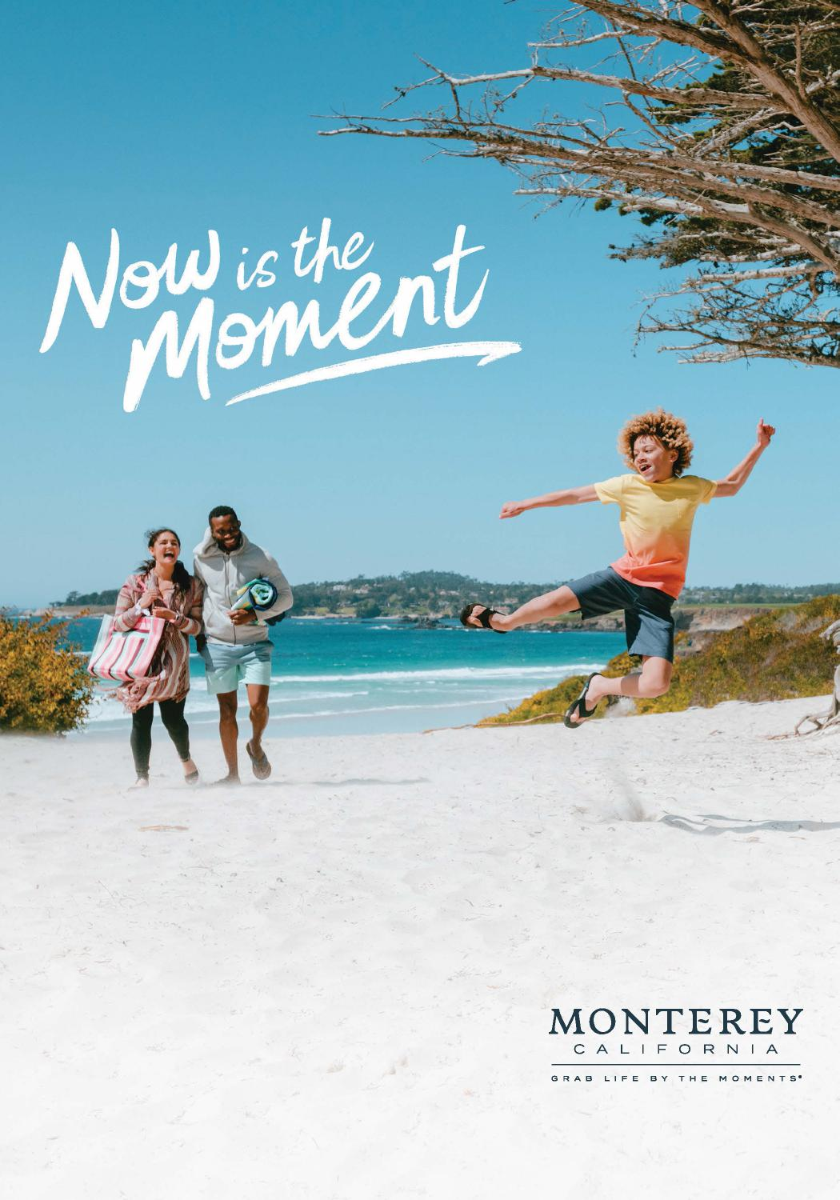
to jump for joy
Your sense of adventure has been dormant too long. It’s time to reconnect and recharge. With amazing historic experiences and stunning backdrops, Monterey County welcomes you. So roll down the windows, buckle up, and hit the road for your next adventure in Monterey County.
SeeMonterey.com/Now
Travel Responsibly.

ROAD TRIPS 2021
5
Klamath Fas
Bookings
MILEAGE CHART
Alturas
Bakersfield
Bishop
Crescent City
Fresno
Los Angeles
Monterey
Ontario
Palm Springs
Redding
Sacramento
San Diego
San Francisco
San Jose
San Luis Obispo
Santa Barbara
Santa Rosa
Dors¹⁶¹ Tulelake
199
395
Yreka
Crescent City
97
139
Aturas
299
96 Mt Shas ta
Weed 4 ,162ft/ Canby
Mount Shasta City ,,317m
REDWOOD NP
Alturas
- 577 374
281 471
689 457
724 676
144 302
810 358
419 571
676 369
89
3
NEVADA
CALIFORNIA
Bakersfield
577 - 227 631 110 112 245
147 216
438 277
233 294
243 122
147 341
Willow Cee
395
299
Arcata
Bishop
374 227 -
618 337
267 350
257 301
400 272
354 368
371 366
322 368
Shasta aLke
299
139
Weavevie
Eureka
LASSEN IVOLCANIC
Crescent City
618 - 549
281 631
729 470 764 834
213 375
850 365
401 585
690 302
Reddng
Fresno
337 549 -
471 110
219 154
254 324
331 171
340 187
151 139
255 234
44
NP
Mt Lassen
0 ,463ft/
3,,189m
44
36
Anderso
Susanvie
Los Angeles
219 - 321
689 112 267 729
37 107
545 385
121 382
341 201
95 428
101
36
Monterey
457 245 350 470 154 321 -
382 451
316 187
465 116
72 145
250 170
Garbeville
Red Bluff
395
70
Ontario
724 147 257 764
254 37
382 - 71
580 420
114 416
375 238
132 463
32
99
Leggett
Quncy
Basden
89
Palm Springs
451 71 -
676 216
301 834
324 107
660 489
137 511
445 308
202 533
70
Paradse
Chico
Orland Wows
Laytonvie Wllis
Redding
144 438
400 213 331 545
316 580
660 - 160
666 216 247 430
535 227
1Reno
45
80
Ooe
Nevada Cty
49
Fort Bragg
Sacramento
302 277
272 375
171 385
187 420
489 160 - 509 87 118 300 400 98
20
5
ruckee
Mendocino
50
20
San Diego
810 233
354 850
340 121
465 114 137 666 509 - 502
461 325
216 549
Colusa
Ukah
Wams
Yuba City 49 Lake Tahoe
Clear Lake Cofax
San Francisco
87 502 -
358 294 368 365
187 382
116 416
511 216
48 232
337 55
1
128
89
16
Point Arena
Anchor BayGuaaa
San José
48 - 186
South Lake Tahoe
419 243 371 401
151 341
72 375
445 247
118 461
291 102
Auburn
Coverdale
Dunngan
Placerville
50
Fafed
San Luis Obispo
232 186 -
571 122
366 585
139 201
145 238
308 430 300 325
106 283
Sea Ranch
Sacramento
E Dorado His
Santa Barbara
106 - 388
676 147
322 690
255 95
250 132
202 535
400 216 337 291
88
Santa
Rosa
395
Jenner
16
Davs
80
4
Santa Rosa
283 388 -
369 341 368 302 234 428 170 463
533 227
98 549
55 102
Jackson
SonomaNapa
5
₁
Petauma
POINT
REYES NS
Mono aLke
108
37 Valejo 12 49
Stockton
Chnese
Camp
IYOSEMITE
San Raael
Concod
4
Berkeley
San Francisco^{Wa}
Oakand
NP
120
Groveand
Manteca
nut Creek
120
CALIFORNIA WELCOME CENTERSSM
Get helpful travel information tips at the state’s official Welcome Centers. Pick up free guides, talk to local experts, and get tips on dining and activities.
395
580 132 6
49 140 Mammoth
Laes
Fremont
San Mateo
Modesto
680
Palo Ato
Mariposa
Oakhurst Bshop
Bg Pne
280
San José
Merced
140
41
17
IKINGS
CANYON
NP
152
Gilroy
Santa Cruz
152
DEATH VALLEY
Mt Whitney NP
14 ,505ft/4 ,421m
Madera
99
180
Salinas
Fresno
Monterey Carmel-by-the-Sea Big Sur
Sema
IPINNACLES NP
145
ISEQUOIA
136Panamint
198 NP Sprngs 190
SHASTA CASCADE ANDERSON • 1699 Highway 273;
530/365-1180
anfod saa
Death Vale Juncton
Shoshone
25
Las Vegas
Oancha
Tulae
ng Cty San Lucas
198
Kettleman City
395
15
178
43
65
101
GOLD COUNTRY
AUBURN • 1103 High St., Suite 150; 530/887-2111 EL DORADO HILLS • 2085 Vine St., Suite 105; 916/358-3700
1
San Smeon
5
eano
155
Rdgecest
Paso Robes
46
127
Cambria
178
46 41
Buttonwow Bakersfiled
14 Mojave
395 Desert
Morro Bay
San Luis Obispo
58
MOJAVE
INATIONAL
PRESERVE
33
SAN FRANCISCO BAY AREA
SANTA ROSA • 9 Fourth St.; 800/404-7673
SAN FRANCISCO • PIER 39, Unit B16, 2nd Level; 415/716-1423
he achap
Pismo Beach 166 Macopa166 15 Kelso
Wheee Rdge 58 Barstow
Gapevne
Needes
Santa Maia
14
40
138
33
Lancaster
Los
Angeles
HIGH SIERRA
TRUCKEE • 10065 Donner Pass Rd.; 530/587-2757
MAMMOTH LAKES • 2510 Main St.; 760/924-5500
Lompoc Sovang
Pamdale Victoville
Mojave
Desert
Santa Barbara
Santa Cata
138
Big
rBear
18
iVda Juncton
101
2
Lake
Pasadena Arrowhead ae Yucca
Hollywood VaeyTwentynne Pas
S
Venua rOxnard
62
an Bernadino
Ontario
CENTRAL VALLEY
FAIRFIELD • Jelly Belly Candy Company, 1 Jelly Belly Lane
rBeverly Hills
Rancho Cucamonga
62Cabazon JOSHUA 177
Malibu
95
Buena Park
Riverside
Santa Monica Torrance
TREE NP
CHANNEL ISLANDS NP
ndo
Anaheim
Pam Sprngs
Bythe
Long Beach
Santa Ana
Deset Cente
10
CENTRAL COAST
GILROY • 8155-6 Arroyo Circle, Building A; 408/842-6436
SALINAS • 1-A Station Place; 831/757-8687
PISMO BEACH • Pismo Beach Premium Outlets, 333 5 Cities Dr. 805/668-7354
Irvine
Huntington Beach
74
86 111
Temecua
San Clemente
Santa
Catalina
Island
79
5
Salton Sea
ANZA-
Avalon
Oceanside ¹⁵Esco nd do
BORREGO
79DESERT SP 78
Centro Wntehaven
LOS ANGELES COUNTY
LOS ANGELES • 100 Citadel Dr.; 323/888-1724
TORRANCE • Del Amo Fashion Center, 3525 W. Carson St.
Del Mar
Apne
La Jolla
Yuma
8
San Diego
94
Chula VistaCoss
Borde Xpess
DESERTS
RIDGECREST • 880 N. China Lake Blvd. Opening 2021
BARSTOW • 2796 Tanger Way, Suite 100; 760/253-4782
CABAZON • Cabazon Outlets, 48750 Seminole Dr.
YUCCA VALLEY • 56711 Twentynine Palms Highway; 760/365-5464
N 0 50 mi
0 100 km
ORANGE COUNTY
SAN CLEMENTE • 101 W Avenida Vista Hermosa; 949/535-2323
INLAND EMPIRE
ONTARIO • Ontario Mills, One Mills Circle, Suite 1054; 909/980-2019
SAN DIEGO COUNTY
OCEANSIDE • 928 N. Coast Highway; 760/721-1101
SAN DIEGO CROSS BORDER XPRESS • 2745 Otay Pacific Drive; 888/229-4636
For more information please go to visitcwc.com
6 | VISITCALIFORNIA.COM

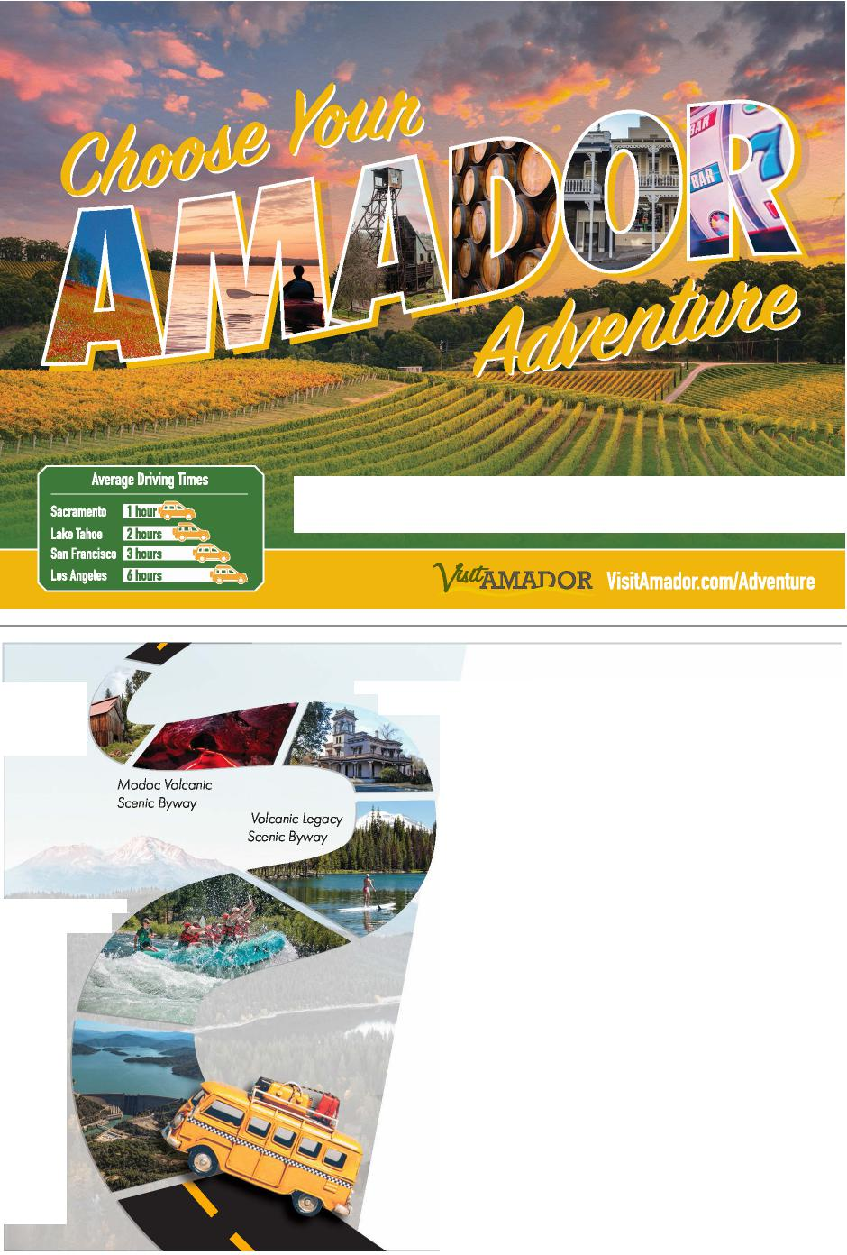
liarrahs anzado 3ANJACKSON
CHERIA
V NORTHERN CALIFORNIA CASINO RESORT

Enjoy the
Feather River Scenic Byway
Historic
Highway 99
ourney
Buckled in is where we are most free.

Looking for an unforgettable road trip? Hop in your car and discover 12 different nationally designated scenic byways winding through the landscape of the Shasta Cascade region. Enjoy the scenic views along the byways as you explore waterfalls, art, caves, lakes, volcanoes, history and more. There's a new sight around every bend in the road - so ditch the crowds and feel the freedom of the open road in UpState California!
Trinity River
Scenic Byway
ShastaCascade.com/Scenic-Drives
(530) 365-7500 • (530) 225-4100

‘UpStateCA SHASTA-CASCADE WONDERLAND ASSOCIATION
Shasta Dam/ Shasta Lake Scenic Byway

ROAD TRIPS 2021

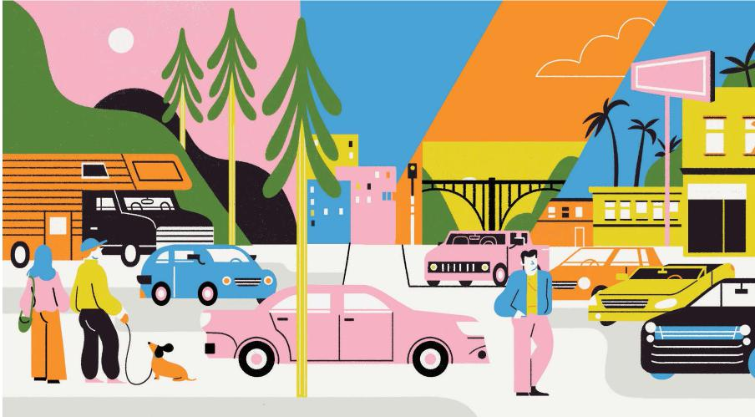
Ensure a Grand Adventure by Renting the Perfect Vehicle
PLAN AHEAD AND MATCH YOUR JOURNEY WITH THE RIGHT SET OF WHEELS

n a road trip, a motor vehicle is much more than a means of conveyance—it’s your home away from home. Due to a nationwide shortage of vehicles, it’s important to book your rental as early as you can. Here are some other essential tips to keep in mind.
O
Factors to Consider
First, nail down the essentials: Driving for five days straight? You need oodles of legroom. Got teenagers in tow? A rear-seat entertainment system and multiple USB ports will keep them happy. Traveling with your dog? Get extra cargo space for muddy paws.
Next, choose features to match your trip: On a drive through the redwoods, a panoramic sunroof lets you gaze at the treetops. For desert journeys, a convertible provides an epic view of the stars. Touring theme parks and beaches? A three-row SUV lets you stash more stuff behind the kids.
Explore Luxury, Exotic, and Eco-Friendly Options
You’re on vacation, so consider giving yourself a novelty boost by renting a car that’s better than the one you drive every day. Are you curious about hybrid or electric vehicles? Rent a Tesla Model S or a Toyota Prius. Or get a glimpse of the future by renting a car that’s smart enough to park itself
and handles other driving tasks autonomously (look into the BMW 7 Series).
And if you’re in splurge mode, slide behind the wheel of a vehicle you’d love to own but can’t justify buying. Every rental car company has a fleet of luxury or exotic cars with models ranging from revved-up Ferraris to rugged Range Rovers. Surf the web and you’ll find Maseratis in Enterprise’s Exotic collection, Porsches in Hertz’s Dream Car collection, and a Jaguar F-Pace in Avis’ Signature Series. You can also roll down the road in a 1960s muscle car from DriveShare or Classic Car Rental, or an ultra-luxe speed machine from Gotham Dream Cars or LA Exotic Rentals.
Home on Wheels
Looking to get closer to nature? Self-contained vehicles like RVs and campervans are more popular than ever. Your whole clan can sleep under the stars while enjoying luxuries like comfy beds and fully stocked refrigerators. Explore your home-on-wheels options at Cruise America (23 California locations) or El Monte RV (12 California locations).
Solo travelers and couples can cozy up with a more minimalist rig, like a campervan from Escape or a converted Dodge Grand Caravan from Jucy. And if you’re headed to SoCal beaches, spoil yourself and rent a 1970s Volkswagen campervan from Vintage Surfari Wagons in Costa Mesa.
ILLUSTRATION BY VERONICA CERRI

8 | VISITCALIFORNIA.COM

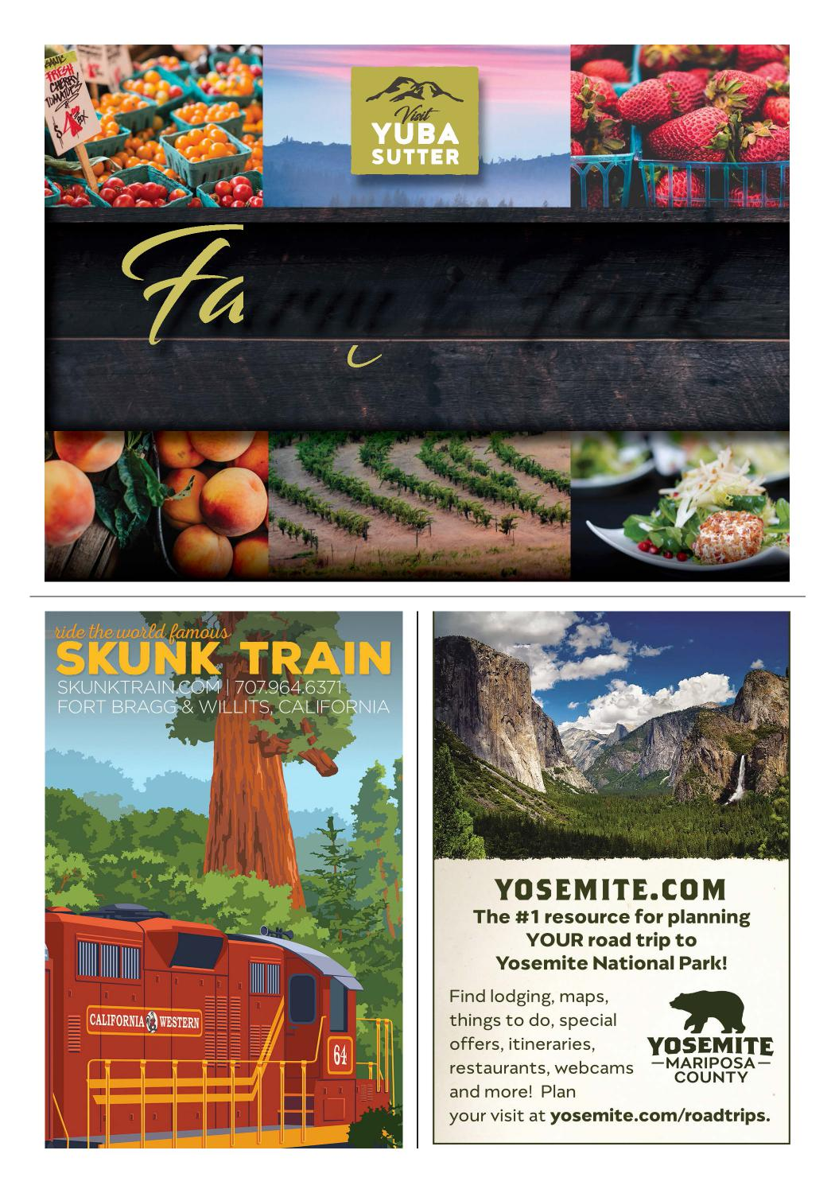
FTAKE A RIDE ON CALIFORNIA’S arm to Fork C
orridor
Yuba and Sutter Counties are home to some of California’s most bountiful farms and farm stands. Take a ride to fresh seasonal cuisine, award-winning wineries, and tranquil scenery.
visityubasutter.com

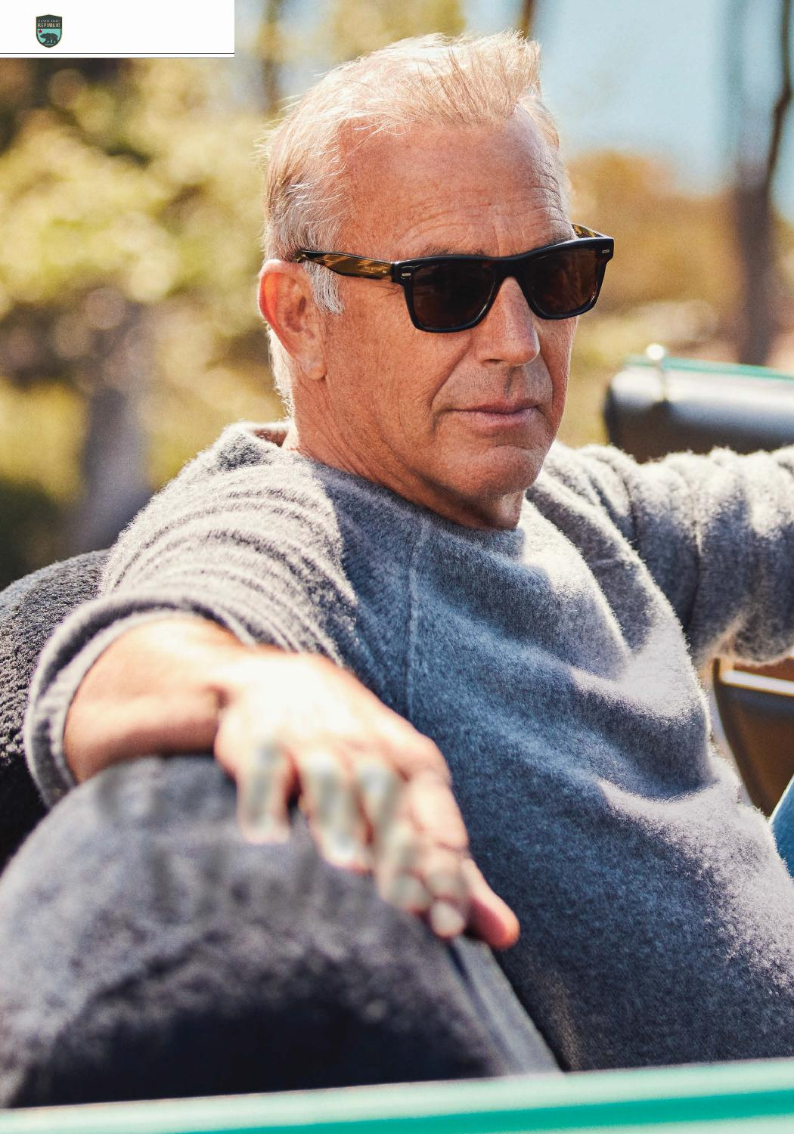
ROAD TRIPS 2021
Going Mobile
KEVIN COSTNER’S LATEST VENTURE, A ROAD TRIP APP CALLED HEARHERE, COMBINES HOLLYWOOD STORYTELLING WITH AUTOMOTIVE ADVENTURING—AND ALLOWS TRAVELERS TO BRING
THE OSCAR WINNER ALONG FOR THE RIDE.
PHOTOGRAPHS BY AMANDA FRIEDMAN

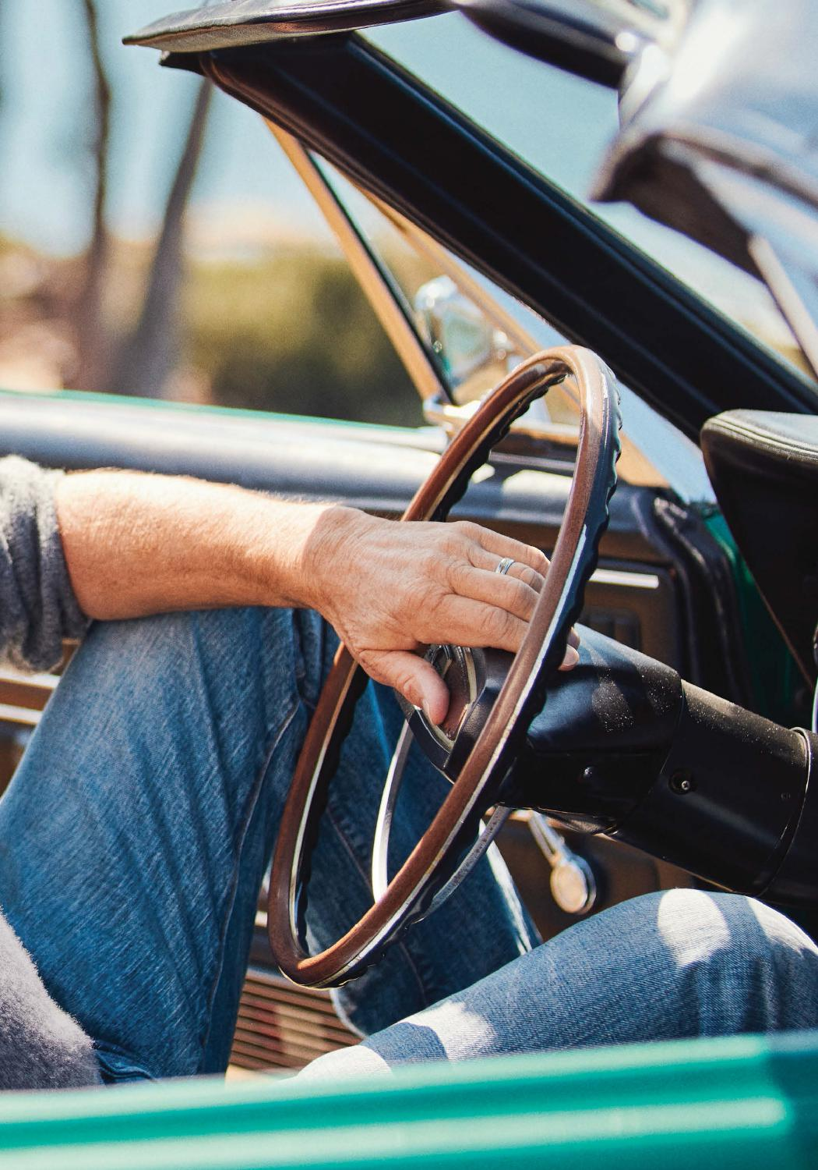
VISITCALIFORNIA.COM | 11

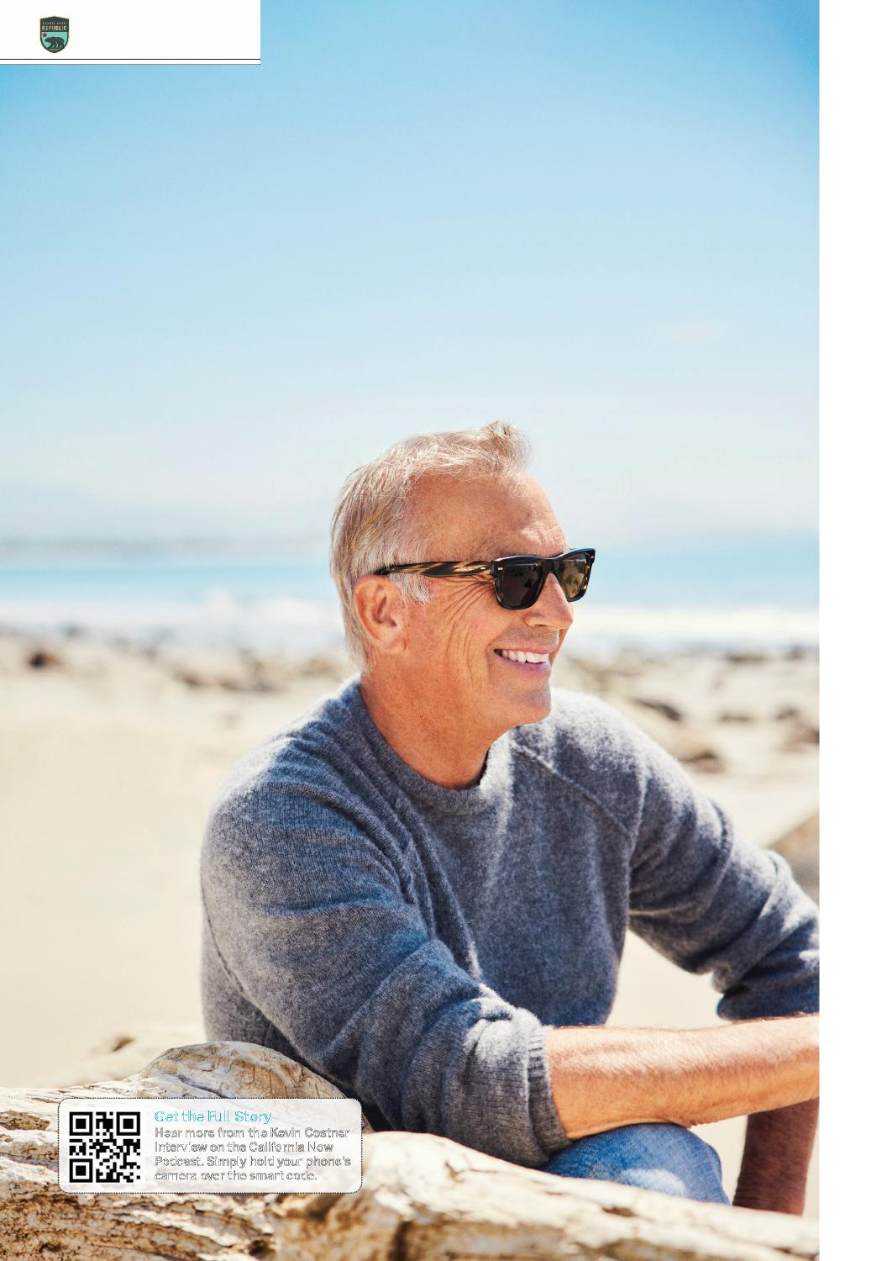
ROAD TRIPS 2021
Kevin Costner,
the award-winning director and star of dozens of movies including Dances with Wolves, Bull Durham, JFK, and Silverado, drives a 1968 Shelby Cobra Mustang that he calls “the quintessential California car.” The sleek convertible matches Costner’s latest project—he’s cofounder of HearHere, a mobile app that enriches road trips with recorded snippets of history and storytelling, offering context for sights along the road.
“I love stories. I’m the guy who stops at the historical markers along the highway, usually bringing moans from everyone in the car,” Costner says. “I am in love with all the edges, all the disappointments, all the progress—all worth knowing.”
Costner grew up in Southern California and started taking road trips as a young boy. “Me
“The summer I graduated, I traveled to all four corners of the United States. But the first half of my trip, I couldn’t hardly get out of California. I wanted so desperately to see the rest of the country, but California just kept calling out to me.”
We asked Costner to take the California Questionnaire and share his favorite aspects of the state, and he agreed. )))
and my brother in the back seat, my dad pushing the sleeping bags down into where your feet would normally go,” he recalls. The family traveled in a Buick with whitewall tires and no air conditioning. “That’s how we saw California, that’s how we saw the other side of the Sierra and the sequoias.”
When Costner hit driving age, he quickly hit the open road.
Get the Full Story
Hear more from the Kevin Costner interview on the California Now Podcast. Simply hold your phone’s camera over the smart code.
12 | VISITCALIFORNIA.COM

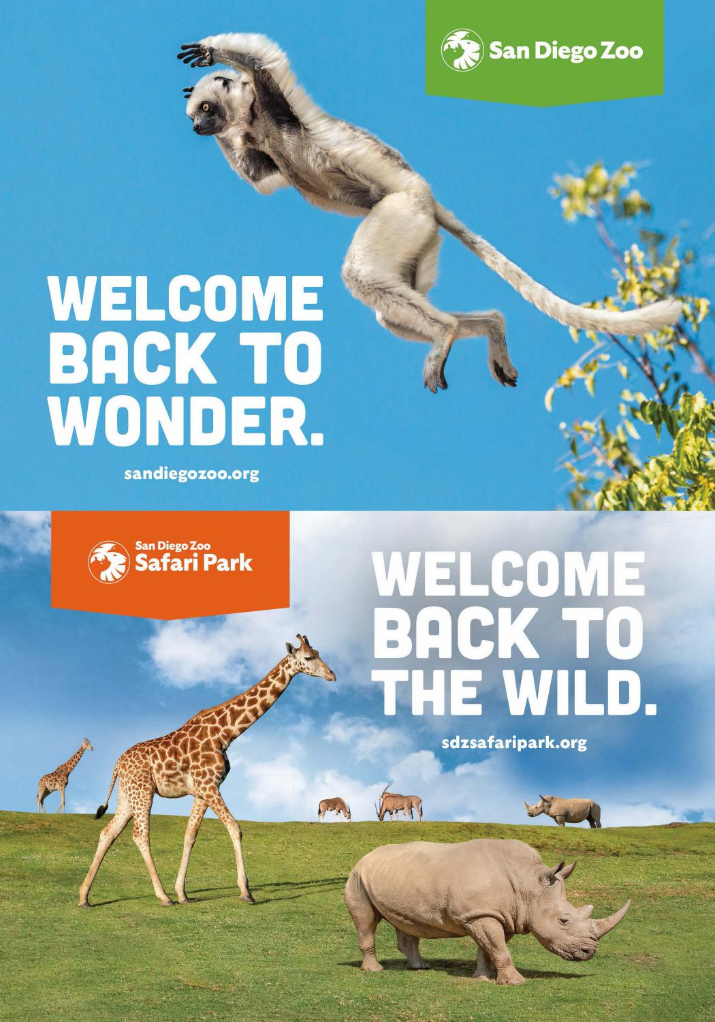

ROAD TRIPS 2021

Kevin Costner’s
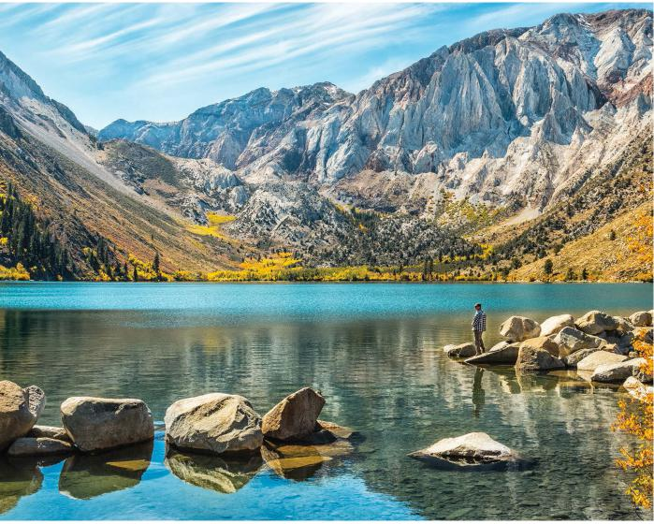
CALIFORNIA QUESTIONNAIRE
Where do you live?
On the Santa Barbara coast.
Why there?
I’ll tell you, I’ve gotten lucky in my life. This is a place that spoke out loud to me, to be on the water with my children and my wife. And so we moved here.
Who or what is
your greatest California love?
The High Sierra. It makes me think of my mother and father, makes me think of the adventures I had. I was going there in diapers and I learned to walk there, so there is something about the Sierra that will never leave me.
What is the biggest misperception about
Californians?
That Californians can’t drive in the rain. Of course we can.
What is the stereotype that most holds true?
It’s expensive to live here.
What is your favorite Golden State splurge?
I’m pretty thankful for In-N-Out. When I’ve been gone a long time, when I just have to get filled up, thank God it’s on the side of the road. I order my burgers animal-style.
Time for a road trip. Where are you going?
I’ve never been able to get the Sierra out of my psyche. When I go there, I’m always refreshed. When I go to the sequoias, it’s the same. I’ve never been able to duplicate that particular smell that comes from the Sierra’s granite mountains. I imagine the reason it smells the way it does is because the pine needles fall, the sun hits them, there’s all that sap.
If you could decree a state culinary experience, what would it be?
I get a lot of satisfaction out of eating at the San Ysidro Ranch. It’s a boutique hotel with a great bar and a great restaurant. And the food ... I just love it.
How do you define California style?
If you’ve got a convertible, you can throw anything in the back and you can go anywhere you want.
What’s the best California song?
Scott McKenzie’s “San Francisco.” It defined an era that I grew up in, during the Vietnam War. I would come through Santa Barbara during ‘67 and ‘68, and there were stop lights—the freeway didn’t go all the way through Santa Barbara. There would be no fewer than 40 or 50 kids at each light, all hitchhiking to San Francisco. My brother was in Vietnam at the time, and so that song was real, not some kind of fairytale. Kids were going to San Francisco and they had flowers in their hair.
How would your California dream day unfold?
Well, I’m kind of living my dream. I never knew that I would have some of the things I have. I live on the ocean. I wake up to it. I like a really good waffle in the morning, and then I love seeing my kids head out on their surfboards right from our house. I think to myself, “I don’t know what I’ve done right in life, but I did this part right.”
DEB SNELSON/GETTY IMAGES

Convict Lake in the Eastern Sierra

14 | VISITCALIFORNIA.COM

© & TM WBE
BOOK YOUR TICKETS AT
WBSTUDIOTOUR.COM

Download on the
App Store
San Francisco from the Beginning
cV 8 ®
San Francisco from the Beginning
HISTORY
AUTHOR HEARHERE PRODUCTIONS
NARRATE. KEVIN COSTNER
LOCATION: SAN FRANCISCO, CA
The history and people that have shaped the Bay Area, starting with the Miwok and Ohlone.
„,tnas
ere,s,enerc1
Golden Gate Beid9e9
San Francisco from the Beginning
HEARHERE PRODUCTIONS
I I

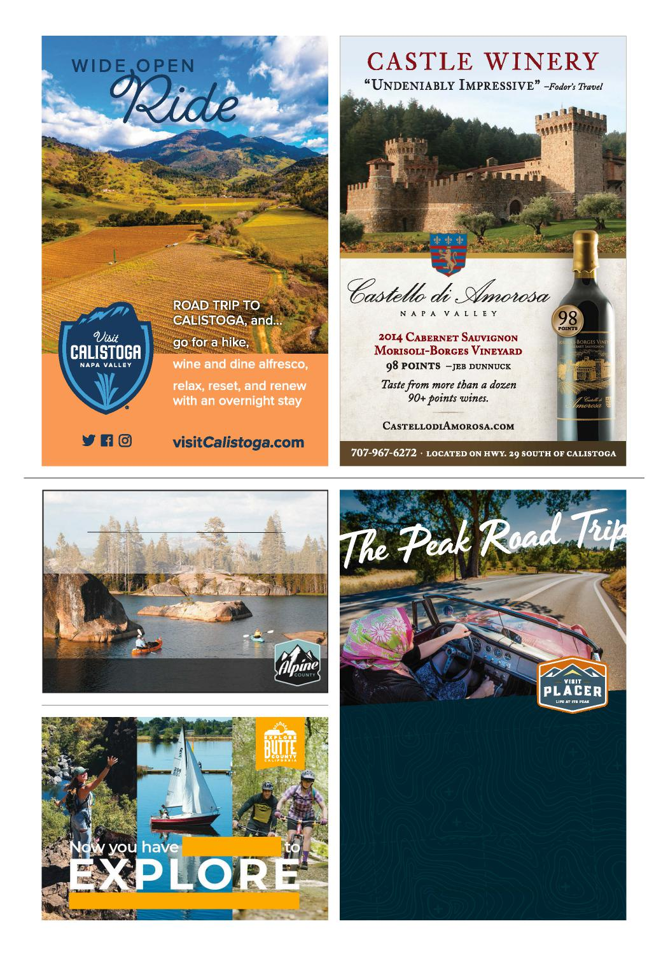
Get Away. Play. Stay.
Bear Valley | Hope Valley| Kirkwood Lake Alpine | Markleeville | Woodfords
www.alpinecounty.com
THE CALIFORNIA ROAD TRIP AT ITS PEAK
#FREEDOM
In Placer County, you never have to ask "are we
there yet?" — every moment of wonder and
adventure speaks for itself. Whether you’re
taking the scenic drive around Lake Tahoe or
stopping to learn about the area’s Gold Rush
history, Placer County’s variety of terrain,
activities and sights make for a fun-filled and
memorable road trip for everyone.
VISITPLACER.COM
Plan your roadtrip at ExploreButteCounty.com

ROAD TRIPS 2021

Gateway Essentials:
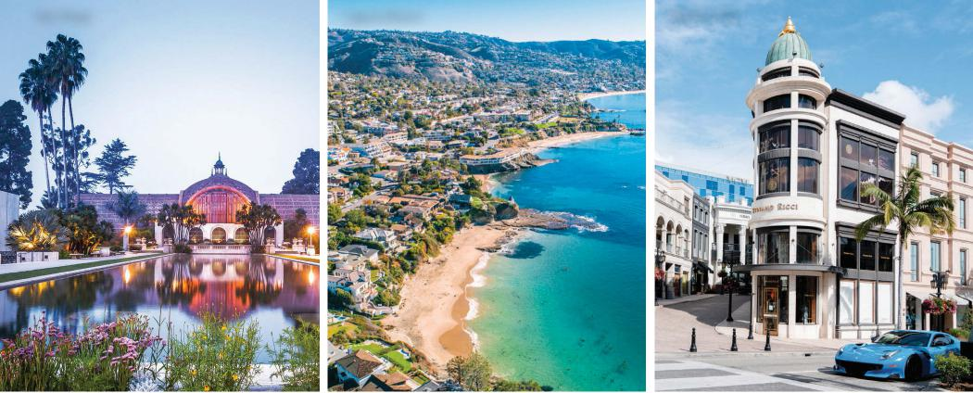
San Diego Laguna Beach Beverly Hills
Southern California

outhern California’s sunny landscape is dotted with dozens of cities that radiate outward from Los Angeles. Seen on a map, they look fairly close together, but more than 100 miles separate the major urban centers of San Diego and Los Angeles. And where exactly does Mickey Mouse call home? Somewhere in the middle.
S
When you’re ready to pack your bags for Southern California, plan your arrival airport carefully. Los Angeles International and San Diego International are the largest, but they might not be closest to your destination. If you’re headed to Disneyland Resort or Orange County’s beaches, consider John Wayne or Long Beach airports. For Universal Studios tours, Hollywood Burbank is convenient. Palm Springs International or Ontario International offer easy access to desert cities. Here’s a quick look at a few gateway highlights.
San Diego
Surf and swim along this sunbaked coastline, or tickle your brain at a staggering collection of museums
in Balboa Park. Glimpse San Diego’s bawdy history at the Gaslamp
Quarter, watch flamenco dancers while sipping margaritas in Old Town, or tour some of the city’s 150 craft breweries. Food trucks serve up everything from fish tacos to Korean street food.
San Diego offers nonstop family-friendly fun: SeaWorld San Diego has ocean creatures from seahorses to sharks. LEGOLAND California builds an entire world with plastic LEGO building bricks. And the San Diego Zoo shows off 650 species, including polar bears, elephants, flamingos, and impossibly cute koalas.
Orange County
Orange County serves up wide, sandy beaches and world-famous surf breaks, and in every coastal town, cliff-top restaurants overlook the setting sun. Newport Beach attracts the yachting crowd, Laguna Beach thrums with the arts, and Anaheim has global dining and breweries.
At Disneyland, your kids can mingle with Mickey Mouse and watch colorful fireworks explode over a fairy-tale castle. Next door is Disney
California Adventure Park, home to the brand-new Avengers Campus. In Buena Park, Knott’s Berry Farm stands out for stomach-flipping roller coasters and a splashy water park.
Los Angeles
Metropolitan Los Angeles has 88 separate towns: Downtown L.A. is a cultural melting pot with Little Tokyo, Chinatown, and a hip art scene. Hollywood and West Hollywood revel in movie glamour, galleries, museums, and Sunset Strip nightlife. In Beverly Hills, shopping is a favorite pastime— even just strolling Rodeo Drive feels indulgent. Santa Monica offers easy-access beaches, boutique shopping, and a bohemian arts scene. Alluring Malibu has epic surf breaks, celebrity mansions, and a wealth of parklands.
Near downtown Los Angeles, Universal Studios Hollywood lets kids step into The Wizarding World of Harry Potter and Jurassic World. Teens love the adrenaline-pumping rides at Six Flags Magic Mountain. The Santa Monica Pier’s aquarium, roller coaster, and Ferris wheel make a beach day even better.
FROM LEFT: LOOP IMAGES/GETTY IMAGES; TRACEROUDA/GETTY IMAGES; AARONP/BAUER-GRIFFIN/GETTY IMAGES

18 | VISITCALIFORNIA.COM

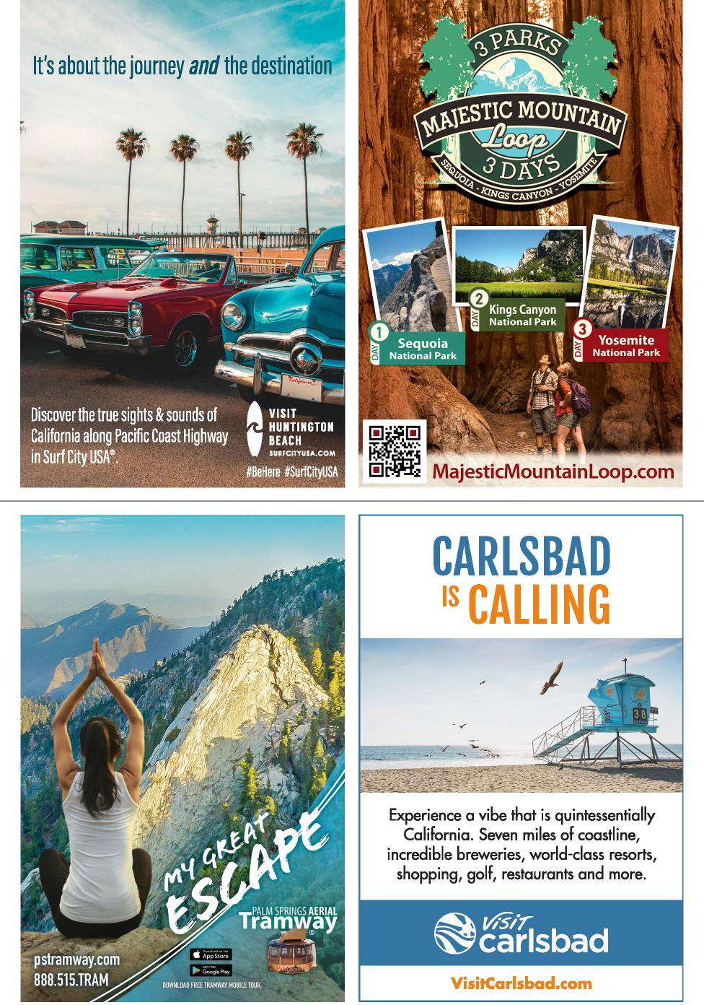
VISIT
HUNTINGTON BEACH
SURFCITYUSA.COM
#BeHere #SurfCityUSA
Discover the true sights & sounds of California along Pacific Coast Highway in Surf City USA®.
w577--
carlsbad
pstramway.com
888.515.TRAM
PALM SPRINGS AERIAL
Tramway
Go gle Play
DOWNLOAD FREE TRAMWAY MOBILE TOUR.
It's about the journey and the destination
lip pi [¹,.¹
lam
-
Yosemite
w ri National Park
MajesticMountainLoop.com
0
CARLSBAD 's CALLING
4.4rolah,
,
Experience a vibe that is quintessentially
California. Seven miles of coastline,
incredible breweries, world-class resorts,
shopping, golf, restaurants and more.
VisitCarlsbad.com

ROAD TRIPS 2021

SAN DIEGO TO BORREGO SPRINGS

DISTANCE: 136 MILES • DAYS: 2–3
San Diego Sojourn
VIBRANT CULTURE MINGLES WITH BREATHTAKING OCEAN VIEWS, ARTSY TOWNS, AND WILD DESERT
OCEANSIDE
LEGOLAND California
BORREGO SPRINGS
San Diego Zoo Safari Park
The Crack Shack
Cedros Avenue
Del Mar Racetrack
Oasis
Camel
Dairy
Mom’s
Pie
House
Borrego
Palm
Canyon

tart your drive with a caffeine fix: Try a cappuccino at Cafe Virtuoso, cold brew at Dark Horse, or Mexican mocha at James Coffee. Then cruise up I-5 to North County, where the locals live by the surf report. First stop: Stylish Del Mar overflows with boutiques and bistros tucked into Tudor-style buildings. Save time to see the thoroughbreds at Del Mar Racetrack, talk to the parrots at Free Flight Bird Sanctuary, or soar through the sky in a hot-air balloon.
S
In Solana Beach, laidback 1960s beach culture mixes with vibrant shopping and eateries. Browse Cedros Avenue for hip clothing and housewares, then fill up at Pizza Port. Just north in Encinitas, try any (or all) of the many chicken sandwiches at The Crack Shack. See a lush collection of palms, bamboo, and succulents at the San Diego Botanic Garden.
A few miles north, Carlsbad is home to kid-fave LEGOLAND California and the colorful flower fields at Carlsbad Ranch. Even if you don’t have kids, plan on an overnight at Cape Rey Carlsbad for easy access to the beach. Take a tour of the Museum of Making Music or shop at Carlsbad Premium Outlets, then enjoy wood-fired dining at Campfire.
For your last coastal stop, linger a while in Oceanside. Get schooled on surfing history at the California Surf Museum, then walk along San Diego’s longest wooden pier (1,942 feet) to watch the surfers below.
Winding Highway 78 carries you inland to Escondido, where
20 | VISITCALIFORNIA.COM
more than 3,000 animals roam around San Diego Zoo Safari Park. Hop on the Africa Tram to see giraffes and rhinos, or zipline above grazing gazelles and elephants. Afterward, stop for burgers and brews at Stone Brewing World Bistro and Gardens, a monument to craft beer.
Forge eastward, pausing in Ramona to snap a selfie with a camel and buy camel-milk soaps at Oasis Camel Dairy. End the day in Julian, a mining town famous for apple pie (dig in at Mom’s Pie House or Apple Alley). Tour the Eagle and High Peak Mine, a key player in the 1870s Gold Rush, then order a flight at Julian Hard Cider’s Miners Saloon, housed in a former apple-packing facility.
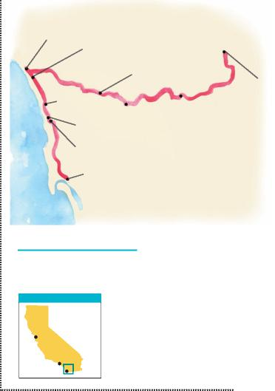
Dark Horse Coffee
Pacific Ocean
SAN DIEGO
WORTH A DETOUR
Flour power: Stock up on jalapeño cheddar bread from Dudley’s Bakery in Santa Ysabel.
AREA OF DETAIL
San
iFrancisco
Los Angeles
Chill out: Go snorkeling in La Jolla, then taste Bobboi’s artisanal gelato flavors: dragon lemon, charcoal vanilla, and vegan pistachio.
San Diego
The final leg zigzags down Banner Grade into the valley of Anza-Borrego Desert State Park. Hike to the fan palm oasis in Borrego Palm Canyon and
look for bighorn sheep clinging to the cliffs. Marvel at the colorful Carrizo Badlands at sunset or sunrise. Drive around Borrego Springs to see large-scale animal sculptures. After sundown, lay out a blanket for Borrego’s dazzling star show. With almost no light pollution, you’ll have a horizon-to-horizon scope on the Milky Way.
THOM MORRIS/GETTY IMAGES
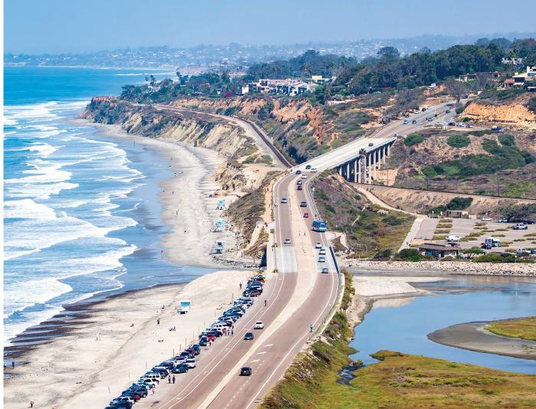
Torrey Pines State Beach

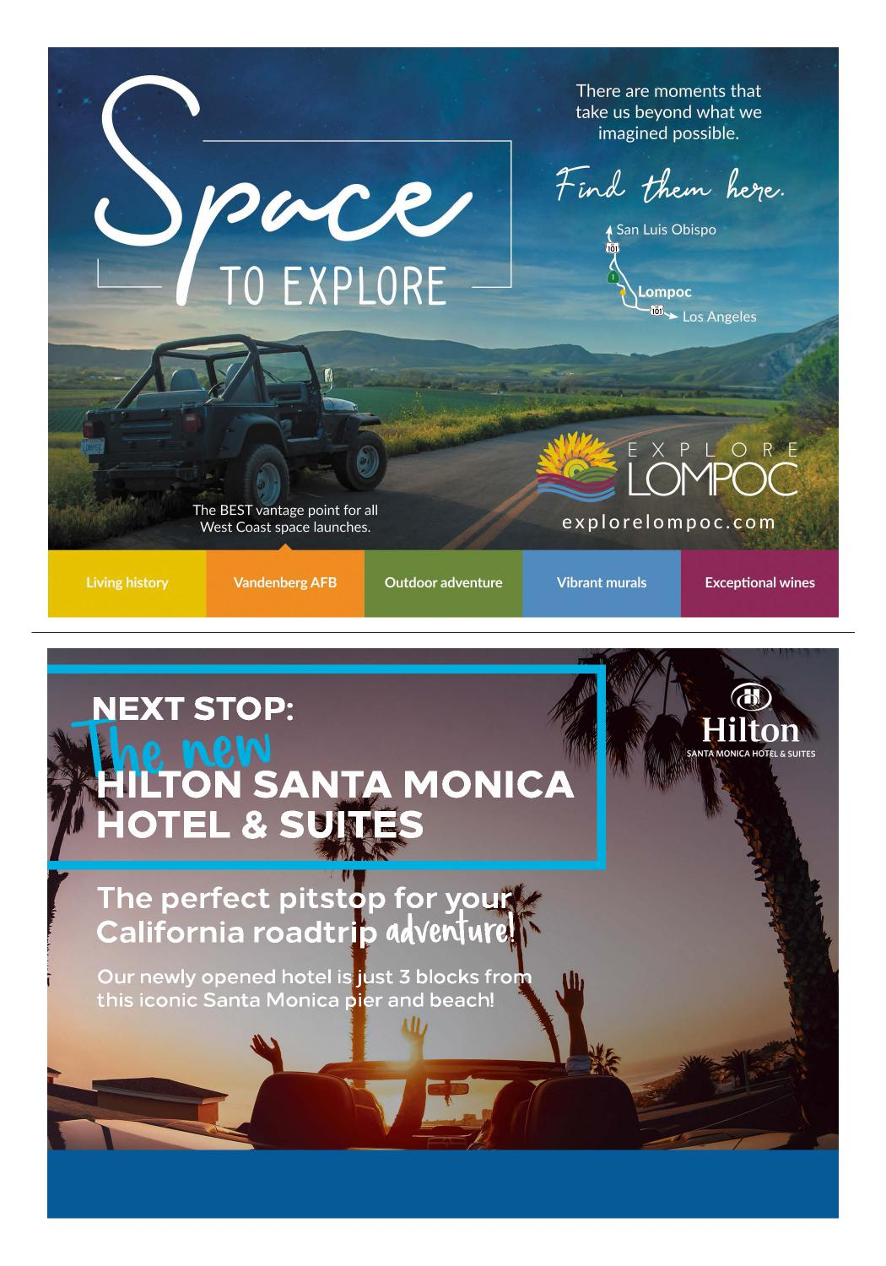
VISIT SANTAMONICA.HILTON.COM TO BOOK TODAY! 1707 4TH ST, SANTA MONICA, CA 90401 | (310) 395-3332

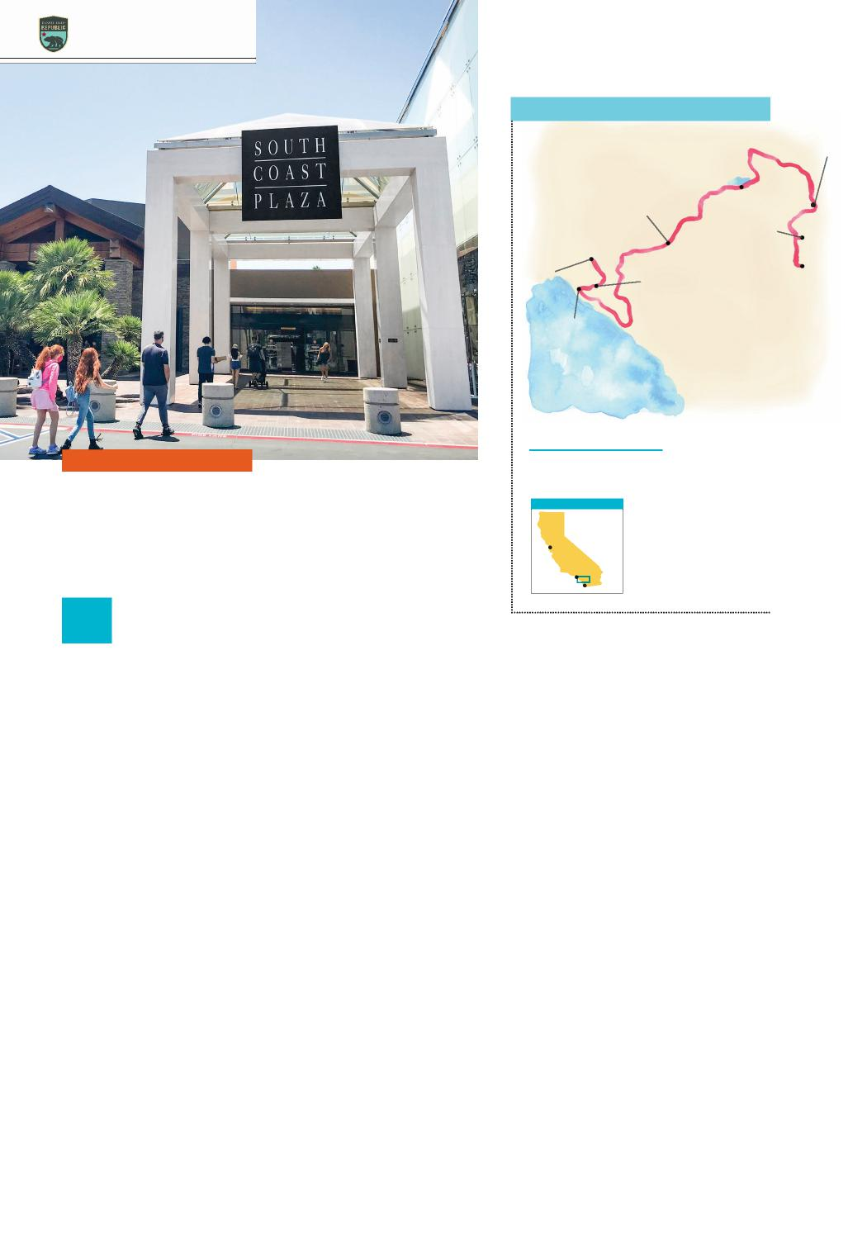
ROAD TRIPS 2021
ANAHEIM TO PALM SPRINGS
McDill
Swim
Beach
Pioneertown
California
Citrus State
Historic Park
ANAHEIM
Two Bunch Palms
Parker Palm Springs
Anaheim
Packing
District
South
Coast
Plaza
PALM SPRINGS
Duke’s
DANA POINT
Pacific Ocean
WORTH A DETOUR
DISTANCE: 255 MILES • DAYS: 2–3
Shop in Long Beach: Browse the offerings on Retro Row and the boutique shops in
Belmont Shore.
AREA OF DETAIL
SoCal Trifecta
San
iFrancisco
EXPLORE BEACH TOWNS, AN ALPINE PLAYGROUND, AND THE SUN-DRENCHED DESERT
Los Angeles
San Diego
Boat tour: Stop in Lake Arrowhead for a narrated tour that includes history, celebrity homes, and movie locations.
B
Push farther south to reach Laguna Beach, an arts-rich town filled with galleries and secluded beaches. When hunger strikes, Splashes’ patio tables are just 25 feet above the beach—feel the ocean breeze while you nosh.
End your day in Dana Point. Check in to the five-diamond Waldorf Astoria Monarch Beach, then select from the resort’s activities: stand-up paddleboard tour, kayaking, snorkeling, or lounging in a chaise.
For this trip’s next leg, head inland and northeast to get to Riverside. Swing by California Citrus State Historic Park to learn about the citrus industry and taste oranges and grapefruits growing on-site.
Trade the lowlands for the mountains by snaking uphill on highways 330 and 18. You’ll see why this stretch is named Rim of the World Scenic Byway—the ridgeline provides spectacular vistas at every turn. When you reach 6,750 feet at Big Bear Lake, park the car and walk through the charming downtown. Indulge in lake-based
ALLEN J. SCHABEN/GETTY IMAGES
leisure at sandy McDill Swim Beach, or get a heart-pumping workout by hiking the granite-strewn trail to Castle Rock.
When you’ve filled up on alpine scenery, head north and east into the desert. As you drive through the Mojave’s landscape of jumbled rocks, make a side-trip to the movie-set hamlet of Pioneertown. You might recognize the wooden buildings, which have starred in more than 50 western films and television shows.
Forge your way into the Coachella Valley to splurge on a suite at Two Bunch Palms Resort in Desert Hot Springs. Soak in the thermally heated tubs to your heart’s content, then make the short jaunt to Palm Springs the next day. Hike amid the Indian Canyons’ palm oases. Shop for mid-century modern furnishings at Modernway or Pelago. Then celebrate with cocktails at the Parker Palm Springs’ speakeasy, Counter Reformation.
egin this Southern California adventure in Anaheim, the city
that mixes Disney magic with culinary wizardry. Anaheim’s Center Street, Packing District, Little Saigon, and Little Arabia dish out global diversity, so choose your meal by culture.
Next, zip over to the coast to shop at Costa Mesa’s South Coast Plaza, followed by a quick tour of the town’s impressive public Art Walk. Hit the Pacific seaside at Huntington Beach and explore 10 miles of sand and surf. Walk the 1,850-foot-long pier, take a surfing lesson, or nab a seat at Duke’s for coastal views and Hawaiian-style seafood.
Cruise south along coastal Highway 1 to Newport Beach, famous for its yacht harbor filled with more than 10,000 boats. Take a gondola ride around Newport Bay, or rent a stand-up paddleboard and sightsee while floating in tranquil waters. Ride the historic ferry to Balboa Island to taste Newport’s signature dish: frozen bananas dipped in chocolate.
22 | VISITCALIFORNIA.COM

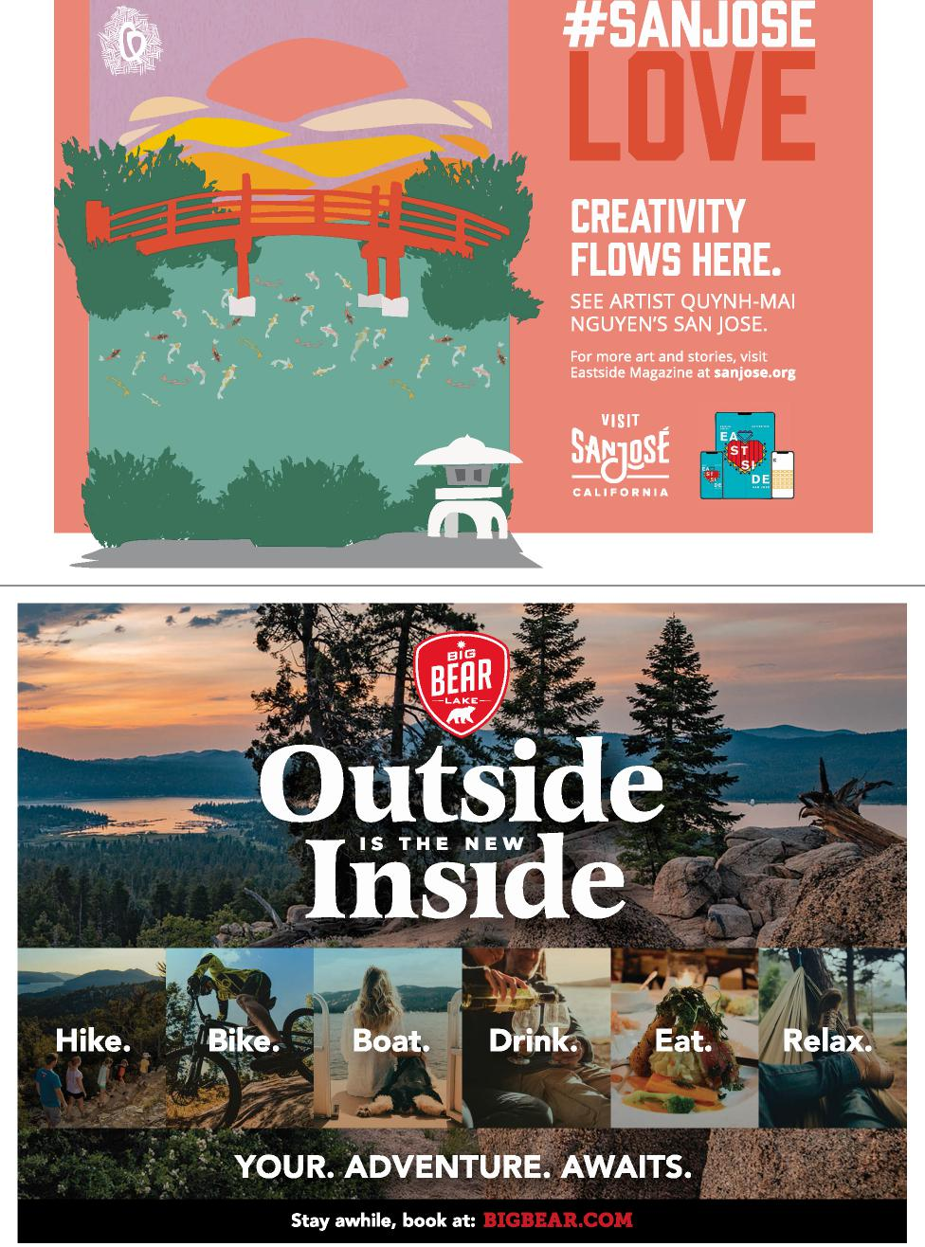
#SANJO E
REATIVITY LOWS HERE.
EE ARTIST QUYNH-MAI
NGUYEN'S SAN JOSE.
JO'
For more art and stories, visit Eastside Magazine at sanjose.org
EA
ST SI
DE
VISIT StOSE
CALIFORNIA
YOUR. ADVENTURE. AWAITS. ;,
Stay awhile, book at: mussr.A.KA.Aore

o prepare for this coastal eye-candy itinerary, first pick up beach necessities at Santa Monica’s Third Street Promenade. Get your thrills with a spin on the Santa Monica Pier’s roller coaster, and marvel at bodybuilders’ glistening biceps at the original Muscle Beach.
ROAD TRIPS 2021
DISTANCE: 239 MILES • DAYS: 2–3
Central
Coast Escape
DISCOVER SUN-SPLASHED BEACHES, WHITEWASHED MISSIONS, AND AN ICONIC CASTLE
T
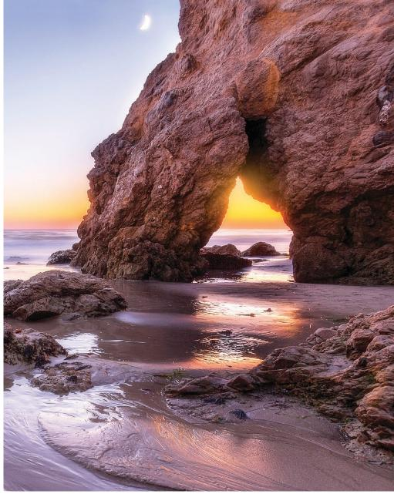
El Matador State Beach
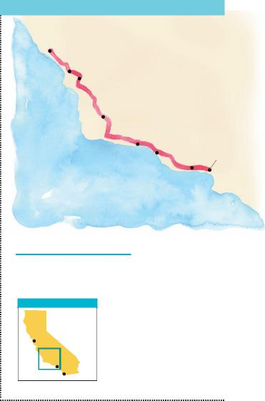
AREA OF DETAIL
Honor history: Head to Camarillo to see exhibits at the Commemorative Air Force
museum and Camarillo Ranch.
Soak and sip: Bathe in natural mineral water at Avila Hot Springs, then order a cocktail at Mr. Rick’s in Avila Beach.
SANTA MONICA TO SAN SIMEON
SAN SIMEON
Hearst Castle
Hofbrau
Madonna Inn
Bob’s Well Bread
SANTA BARBARA
Surfer’s Point
Third Street Promenade
SANTA MONICA
Pacific Ocean
WORTH A DETOUR
San Diego
San
iFrancisco
Los Angeles
Paradise
Cove Beach
Café
JINNA VAN RINGEN PHOTOGRAPHY/GETTY IMAGES
Head north on Highway 1, pulling over to sink your toes in the sand at Will Rogers State Beach in Pacific Palisades. Do some California dreamin’ as you drive past mansions in Malibu, then stop for fish tacos at Paradise Cove Beach Café. Relax on Zuma Beach or hike to El Matador State Beach’s famous rock formations.
Wind inland through Oxnard’s farm country and pop out on Ventura’s coast, where every day seems like endless summer. West of Ventura Pier, watch the longboarders at Surfer’s Point, then hunt for treasures at secondhand stores on Main Street.
A short jaunt north leads to Santa Barbara, a postcard of Spanish colonial architecture and swaying palms. Watch for dolphins as you sunbathe on Butterfly Beach. Admire the Santa Barbara Mission’s twin bell towers before you plunge back into modern times in the Funk Zone, a vibrant district with groovy galleries and shops.
Heading north, U.S. 101 hugs the coastline, offering sweeping views of the Pacific before jogging inland to Los Alamos. Beneath the ranchland exterior of this tiny town lies a buzz
ing food scene. Bell’s serves Parisian-quality fare, Bob’s Well Bread bakes artisan loaves, and Charlie’s takes burgers to the next level.
Rolling hills and vineyards flank the route to scenic San Luis Obispo. Swing by the ostentatiously pink Madonna Inn before heading downtown for tapas overlooking Mission Plaza at Luna Red. Check into The Kinney San Luis Obispo, a mid-century mod-ern–style hotel with outdoor fire pits. Sleep well, then pick up your morning chai tea at Linnaea’s Cafe.
More coastal splendor awaits, so move along Highway 1 to Morro Bay. Gaze at the marvel of Morro Rock, rising 576 feet above the bay. Get eye-to-eye with wildlife on a kayak tour of Morro Bay’s estuary. Lunch on bratwurst at the bay-side Hofbrau, watching fishing boats haul in their catch.
Continue north, passing the beach town of Cayucos and blink-and-you’ll-miss-it Harmony, before landing in Cambria, which overflows with galleries and boutiques tucked among coastal pines. Search for sea stars in the rocky tide pools at Leffingwell Landing, then refuel with a slice of olallieberry pie at Linn’s.
Expect jaw-dropping ocean views along every curve to San Simeon. Pull over at Piedras Blancas for a close-up look at massive elephant seals.
Transition from nature to culture with a drive up to Hearst Castle, a 115-room mansion filled with artifacts from around the globe. Take a tour, then take in the grandest sight of all—the sun setting over the Pacific Ocean.

24 | VISITCALIFORNIA.COM

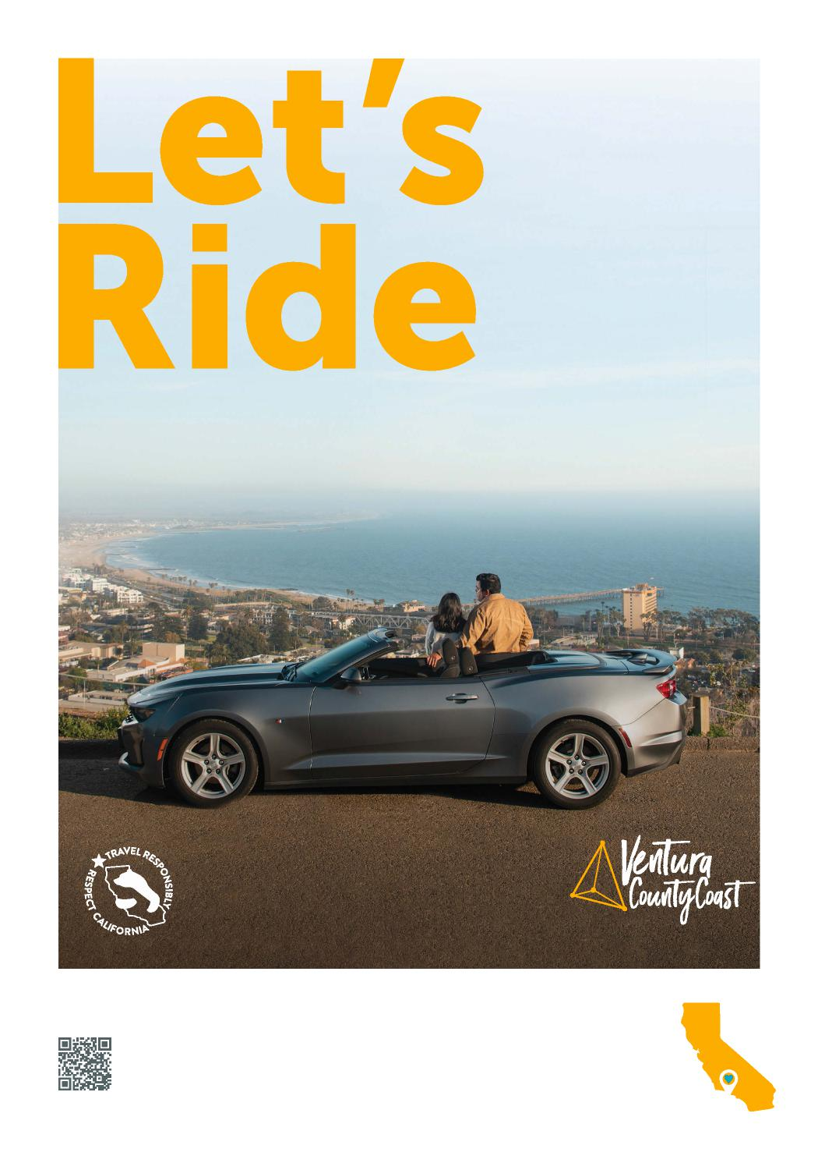
OPEN ROADS. CHILL VIBES.
CALIFORNIA
V E N T U R A C O U N T Y C O A S T. C O M / R O A D T R I P
CAMARI LLO OXNARD VENTURA
PORT HUENEME

ROAD TRIPS 2021

Gateway Essentials:
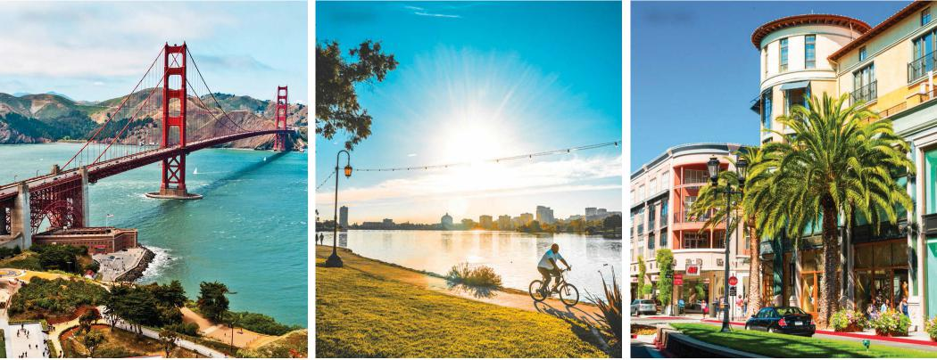
San Francisco Oakland San Jose
Northern California

he San Francisco Bay Area is famous for its independent, left-coast culture—it’s a place where tech nerds, foodies, and creatives feel right at home. Its unique geography contributes to its edginess: San Francisco sits on a peninsula, hugged by the Pacific Ocean and San Francisco Bay, linked to neighboring cities by a handful of scenic bridges.
T
The area’s three main airports are all within an hour of one another, but you can streamline your getaway by picking the best fit for your itinerary. Arriving at San Francisco International makes it easy to visit San Francisco, Marin County, or the Redwood Coast. If you’re heading toward Big Sur or Santa Barbara, San Jose International is the most convenient choice. And for Yosemite, Lake Tahoe, or Mount Shasta, Oakland International is the closest option.
San Francisco
The City by the Bay has dozens of must-sees: Bundle up for a windy walk across the Golden Gate Bridge. Head to Fisherman’s Wharf to watch the sea lions and taste fresh Dungeness crab. Visit the Ferry Building’s farmers market and boutique shops.
Admire the works of modern masters at SFMOMA. Explore Chinatown’s apothecaries, curio shops, and dim sum restaurants. Wander through Golden Gate Park’s superb museums to see art at the de Young, flora at Strybing Arboretum, and nature at the California Academy of Sciences. Cruise across the bay for a tour of Alcatraz prison.
Kids love Fisherman’s Wharf, especially PIER 39’s sunbathing sea lions and the Aquarium of the Bay. At Pier 15’s Exploratorium, exhibits encourage kids to play like scientists. Explore the Children’s Creativity Museum in Yerba Buena Gardens or the Walt Disney Family Museum in the Presidio.
Oakland
Dynamic, artsy Oakland and surrounding East Bay cities are packed with lively music venues, legendary bookstores, and global restaurants. Browse waterfront boutiques, tour a historic ship, and savor bayside splendor at Jack London Square. Shop your way through the hip Rockridge District, filled with high-end clothing shops and boutiques selling luxury home goods.
Take the kids to Tilden Park, where they can feed farm animals or ride a miniature steam train and a hand-carved antique carousel. Check out the planetarium at the Chabot Space & Science Center, and see exotic animals at the Oakland Zoo.
San Jose
California’s third-largest city is packed with worthwhile stops like The Tech Interactive, with exhibits on computers, robotics, and space exploration, and San Pedro Square Market, a lively food hall. The light-filled San Jose Museum of Art features works by contemporary California artists, and History Park offers a glimpse into San Jose’s life before it became Silicon Valley’s civic heart. Santana Row offers 70-plus shops where you can indulge your fashion sense.
Kids love touring the quirky Winchester Mystery House and marveling at mummies and tombs at the Rosicrucian Egyptian Museum. Take the younger set to the Children’s Discovery Museum, a big purple building filled with interactive arts and technology exhibits for kids 10 and under.
FROM LEFT: STEVE PROEHL/GETTY IMAGES; COURTESY VISIT OAKLAND; DAVEL5957/GETTY IMAGES

26 | VISITCALIFORNIA.COM

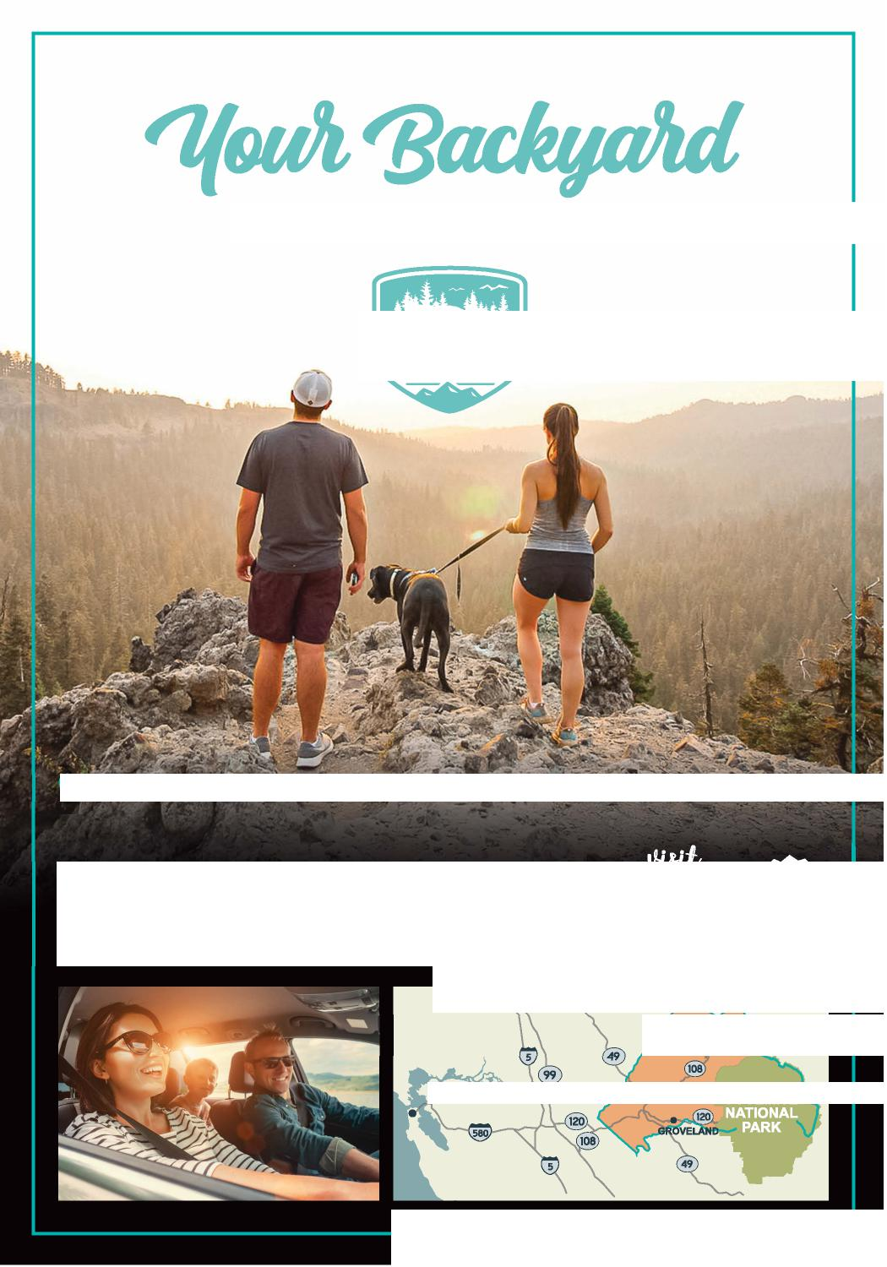
JUST GOT A LOT BIGGER
^{I}FREELY
- TRAIL OF THE GARGOYLES, STANISLAUS NATIONAL FOREST*

Discover the beauty of road tripping through Tuolumne County - an easy getaway, 2.5 hours east of the San Francisco Bay Area, with miles of fresh air, outdoor adventure and charming historic towns. From hiking and kayaking to strolling unique shops and enjoying local cuisine, there's plenty to explore throughout the High Sierra, Gold Country and Yosemite. When you're ready to wander freely, we're here to welcome you back safely. VisitTCToday.com/Roal,
TUOLUMNE
county
YOSEMITE. GOLD COUNTRY*HIGH SIERRA
CALIFORNIA
SACRAMENTO
TUOLU COU
SAN FRANCISCO

*Photo credit Zach Holback

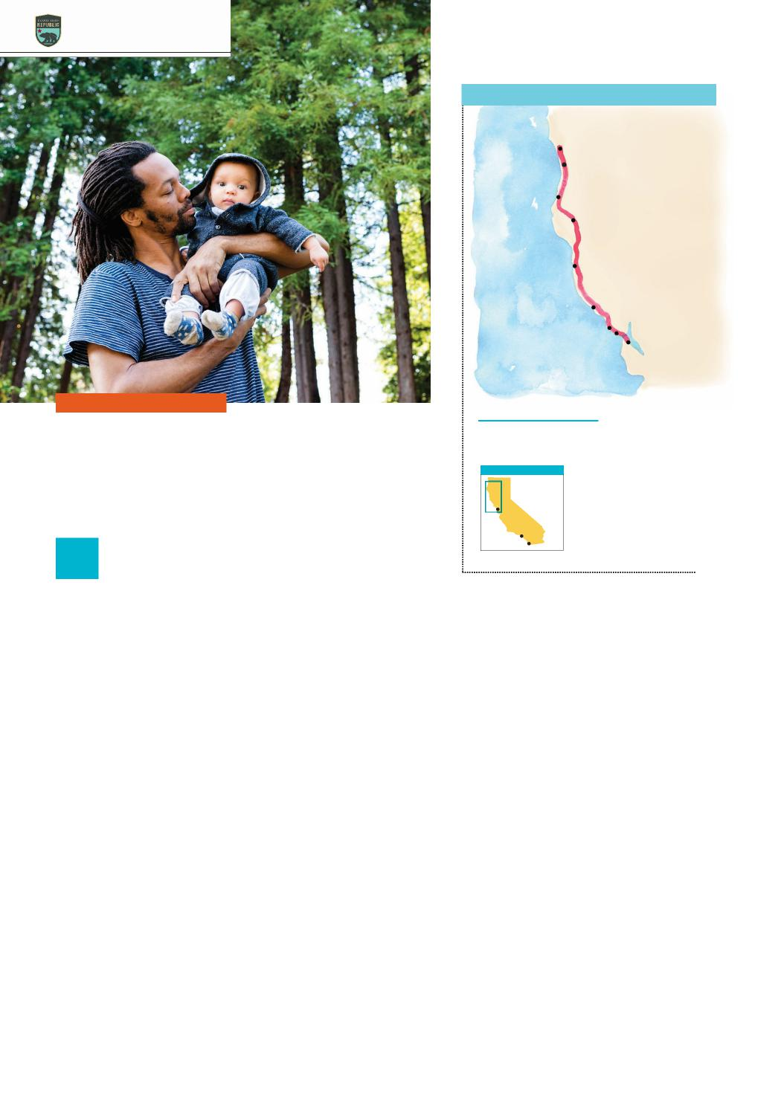
Mendocino
ROAD TRIPS 2021
SAN FRANCISCO TO CRESCENT CITY
CRESCENT CITY
SeaQuake Brewing
Hidden Beach
Katy’s Smokehouse
Avenue of the Giants
MENDOCINO
Pacific Ocean
Timber Cove Resort
Point Reyes
National
Seashore
Parkside Cafe
SAN FRANCISCO
DISTANCE: 407 MILES • DAYS: 3–4
WORTH A DETOUR
Golden Gate to Big Trees
AREA OF DETAIL
EXPLORE NORTHERN CALIFORNIA’S PRISTINE COASTLINE
San Francisco
Los Angeles
San Diego
S
Retro Americana: Ferndale’s brightly painted Victorians house 1950s-style
diners and old-time five-and-dimes.
Forest bathing:
Near Orick, marvel at the towering trees in Prairie Creek Redwoods State Park.
known as “tafoni.” End your day at Timber Cove Resort, perched atop seaside bluffs.
The next morning, you’re off to the village of Mendocino. Fill your day by kayaking near sea caves at Van Damme State Park, lounging on the sand at Jug Handle State Natural Reserve, and trekking to the waterfall at Russian Gulch State Park. Taste line-caught seafood at Trillium Cafe or Wild Fish, and spend the night in an ocean-view room at Little River Inn.
North of Fort Bragg, Highway 1 doglegs inland on a circuitous route to Leggett and U.S. 101. Snap a selfie as your car creeps through the Chandelier Tree, a 2,400-year-old redwood with an auto-sized tunnel carved into its trunk. Proceed north to Phillipsville and the Avenue of the Giants, a 32-mile redwood-rich alternate to U.S. 101.
Cap off your day in the artsy town of Eureka, home to grand Victorians like the yellow landmark housing Lost Coast Brewery. Take a self-guided walking tour of Old Town’s color-
LINDSAY UPSON/GETTY IMAGES
ful murals, then zip over to Sea Grill for freshly caught seafood.
The next morning, follow U.S. 101 north to Trinidad, a picture-perfect seaside hamlet. Climb to the top of Trinidad Head to look for whales. Stock up on smoked seafood at Katy’s Smokehouse, then hike paths along the dramatic coastline of Patrick’s Point State Park.
Keep trucking north to Klamath. Drive out to the Klamath River Overlook to see the magnificent meeting place of this 250-mile-long river and the Pacific. Walk along the Coastal Trail, or drive north to hike the Yurok Loop to Hidden Beach, where driftwood piles up on windswept sand. Spend a night in Crescent City and visit the 1856 Battery Point Lighthouse, then beachcomb for agates at Pebble Beach. Savor fish tacos and artisan ales at SeaQuake Brewing before squeezing in one more hike in Jedediah Smith Redwoods State Park.
tart on San Francisco’s northwestern edge, enjoying blue-water
views while crossing the Golden Gate’s orange splendor, then steer into Marin County’s coastal headlands.
Pick up two-lane Highway 1 in Mill Valley, which curves its way to bohemian Stinson Beach. Take a break to nosh on a burger at Parkside Cafe, then push north to Point Reyes National Seashore, a peninsula bounded by beaches, lagoons, and estuaries. Choose a trail by wildlife: Roam across Tomales Point to see tule elk, Abbotts Lagoon to spot birds, or Chimney Rock to scan for whales.
Beyond Point Reyes, your car skirts Tomales Bay, one of California’s best oyster-producing regions. Stop and taste the bivalves at The Marshall Store.
Wind northward past Bodega Bay and a tableau of wind-lashed headlands and grassy blufftops. Pull over at Salt Point State Park and walk alongside Gerstle Cove to see sandstone dotted with honeycomb-like holes and caves
28 | VISITCALIFORNIA.COM

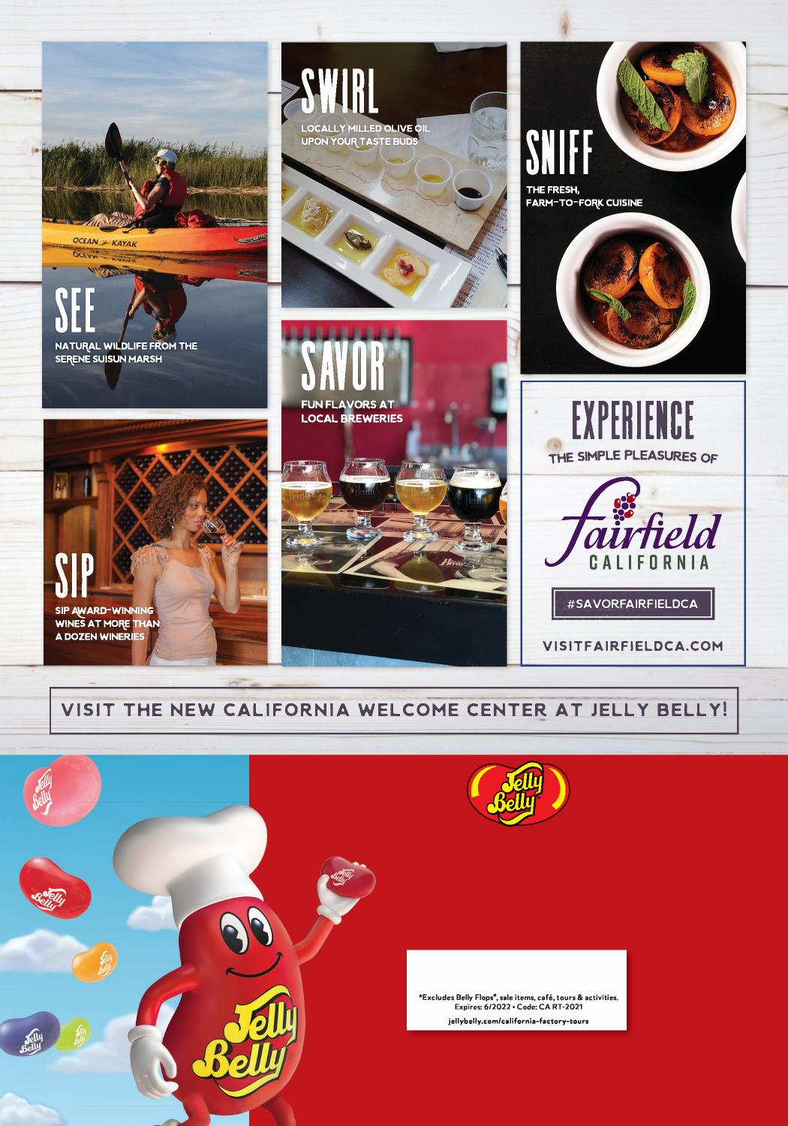
Factory Tours
DAILY 9:15AM–4pM
- Self-guided factory tour
- Fun, interactive and sensory exhibits
- Chocolate & Wine Experience
20% off!*
P U R C H A S E
®
Jelly Belly Visitor Center • One Jelly Belly Lane • Fairfield, CA JellyBelly.com • 800-953-5592
© 2021 Jelly Belly Candy Company

tart with a Southern-style breakfast at Aunt Mary’s Cafe in Oakland, then take Highway 24 through the East Bay’s grassy hills and descend into the Central Valley’s vast plains.
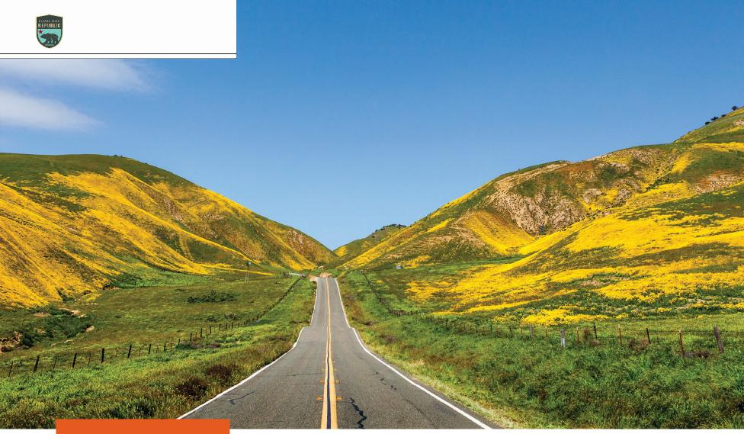
ROAD TRIPS 2021
Carrizo Plain National Monument
DISTANCE: 475 MILES • DAYS: 4–5
Bounty & Beauty
TRAVEL THROUGH THE FERTILE CENTRAL VALLEY EN ROUTE TO THREE AMAZING PARKS
S
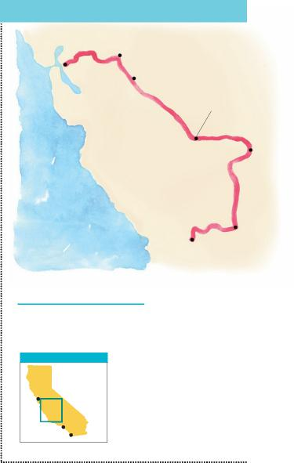
Sequoia & Kings Canyon National Parks
OAKLAND TO CARRIZO PLAIN
FRESNO
OAKLAND
The Fruit Bowl
Aunt
Mary’s
Cafe
VanderHelm Farms
Simonian Farms
Padre Hotel
Pacific Ocean
CARRIZO PLAIN
WORTH A DETOUR
Diablo vista: Near Walnut Creek, the Summit Museum on 3,849-foot Mount Diablo
provides an astounding 360-degree view from its stone observation deck. Cheesy goodness: Visalia’s Quesadilla
Gorilla serves world-class Mexican comfort food.
AREA OF DETAIL
San
iFrancisco
Los Angeles
San Diego
GARY KAVANAGH/GETTY IMAGES
Resist the urge to speed through the flatlands—if you do, you’ll miss out on prime salad-bowl country. Start with a bucket of peaches at The Fruit Bowl in Stockton. Then produce-shop your way down Highway 99. In Modesto, you can pick your own berries or stone fruit at VanderHelm Farms. In Merced, grab a bottle of wine at Vista Ranch.
As you cruise into Fresno, pull over at Simonian Farms, a 1901 family-run fruit stand, to sample the French burnt peanuts and dried nectarines. Spend a few hours in Fresno’s Tower District, a hip neighborhood with vintage boutiques, brewpubs, and restaurants.
Next, travel east on Highway 180 to Kings Canyon National Park to get your first look at giant sequoia trees in Grant Grove. A short loop trail
connects the 2,000-year-old General Grant Tree with dozens of leviathans.
Drive south on the Generals Highway to Sequoia National Park to see more amazing trees in Giant Forest. Stare in awe at the General Sherman—the largest living thing by volume—then walk the two-mile Congress Trail, which shows off dozens more sequoias. End the day with a climb up Moro Rock’s 370 granite steps to take in the vista of the Great Western Divide.
Next, zigzag through 130 curves to exit the park and drive west to Exeter. Walk along Pine Street and surrounding blocks to see 27 colorful
murals celebrating the area’s agricultural heritage. Then zoom south to Bakersfield and check in at the swanky Padre Hotel, famous for its cowboy sophistication.
Next, head west to “Califor-nia’s Serengeti,” Carrizo Plain National Monument. This vast region contains California’s single largest native grasslands, where tule elk and pronghorn roam, and rare birds abound.
Spring wildflowers draw a crowd, but there are amazing sights year-round. Walk the boardwalk trail at ephemeral Soda Lake, and you might spot an array of wintering raptors. Or stretch your legs on the Caliente Ridge Trail, a 7-mile ridgeline path with panoramic views.

30 | VISITCALIFORNIA.COM

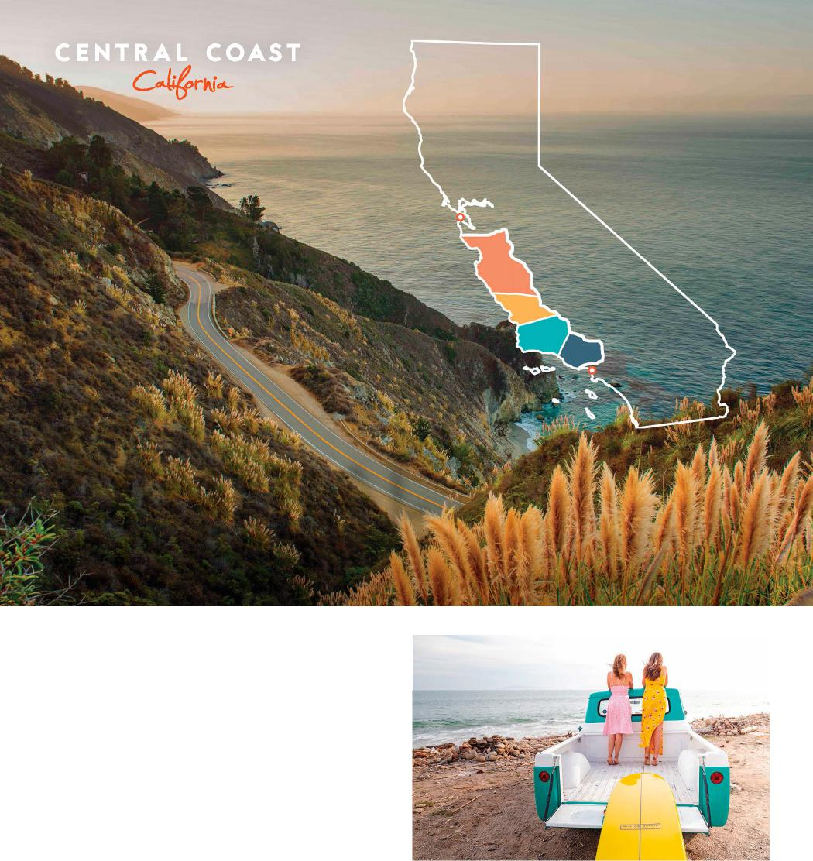
VENTURA HARBOR VILLAGE
San Francisco
Los Angeles
EXPLORE THE
CENTRAL
COAST
TheOriginalRoadTrip.com
VENTURA
Ventura Highway, in the sunshine. With a
new 2,100 acre nature preserve made for
hiking and mountain biking, and wide
sea-whisper beaches, Ventura really is the
perfect road trip song. America immortalized
the Highway. But the real magic happens
when you step away from the road.
visitventuraca.com | 805/641-1400
A vibrant harbor boasting seaside attractions, boutiques, fresh seafood restaurants, water rentals, artisans, family fun, sweet treats, self-care, patio dining & variety of cuisines at Ventura Harbor Village. Home of Channel Island National Park & Visitor Center, stay at waterfront hotels, explore beaches, whale watching, diving, sportfishing & Channel Island trips. Come live your best California coastal lifestyle!
venturaharborvillage.com | 805/477-0470

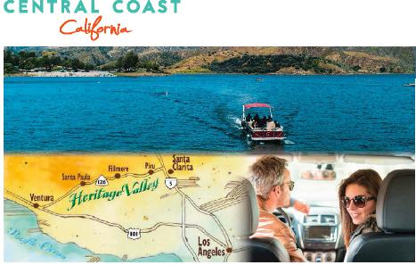
HERITAGE VALLEY
Scenic Highway 126 through Heritage Valley offers the ultimate escape! Between Ventura and Valencia, discover the historic towns of Santa Paula, Fillmore and Piru, and the Rancho Camulos National Historic Landmark. Enjoy our natural bounty of produce, honey and wine. Visit unique shops, restaurants and boutique hotels, ride a vintage railway or hot air balloon, discover outdoor adventures and ExploreLakePiru.com!
heritagevalley.net | 805/524-7500
SANTA BARBARA’S BEACHFRoNT
Cabrillo Inn at the Beach...Enjoy Swaying Palms, Sea breezes and an orchestra of ocean waves at a surprisingly affordable rate. It’s your vacation and you deserve to relax! Enjoy ocean & island views from your room or our two 2nd floor Sundecks. 90° heated pool. To hit “East Beach”, just cross the street. Ask about: “Free Nights” & Vacation Rentals. Book Direct and Save. $99-$499.
cabrillo-inn.com | 800/648-6708
SANTA YNEz VALLEY
Two hours north of LA and four hours south of San Francisco, the Santa Ynez Valley feels worlds away. In the towns of Ballard, Buellton, Los Alamos, Los Olivos, Santa Ynez, and Solvang, travelers will find more than 100 wineries, a thriving culinary scene, outdoor adventure, and wide-open spaces to relax, rejuvenate and explore.
visitsyv.com
BuELLToN

#SkipTheBigCities and head to Buellton. Nestled in the STA. Rita Hills wine region, you’ll also enjoy feeding an ostrich, taking a stroll through the botanic garden or enjoying the collection at Mendenhall’s Museum of gasoline pumps & petroliana. You’ll find accommodations for all budgets including “glamping”.
discoverbuellton.com

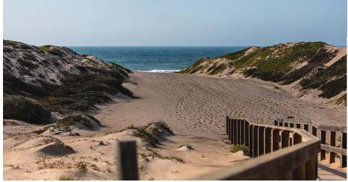
VISIT SANTA MARIA VALLEY
Make Santa Maria Valley the home base for your Central Coast getaway and do more, for less. Here, you’ll find plenty of wide-open spaces with 13 beaches, 24 hiking trails, and more than a dozen wineries and tasting rooms, all within a 30-minute drive.
santamariavalley.com | 805/925-2403

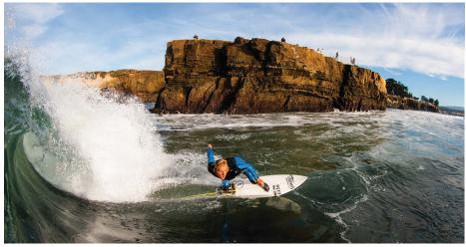
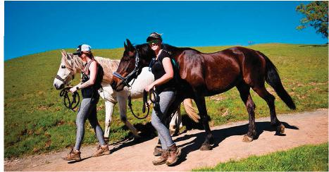
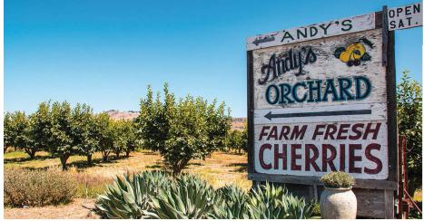
TheOriginalRoadTrip.com
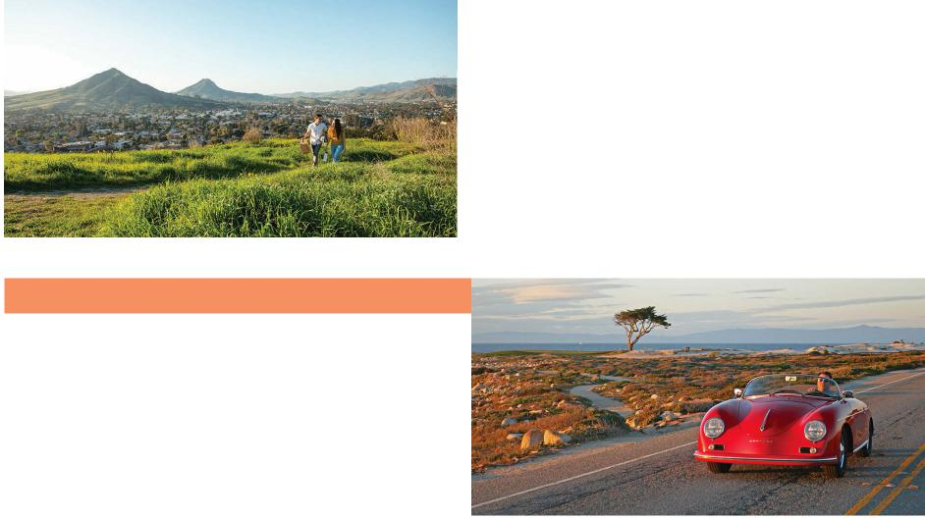
VISIT SANTA CRUZ COUNTY
SAN LUIS OBISpO
Escape to San Luis Obispo, a must-stay destination on your Central Coast road trip. With endless sunshine, historic sites, and wineries galore, you can fill your soul (and your belly) with quintessential California goodness. Wine, dine, bike or stroll in SLO, dubbed the “Happiest City in America.”
visitslo.com | 877/756-8696
MONTEREY TOURING VEHICLES
Monterey Touring Vehicles is the only
company on the Central Coast that provides
the opportunity to rent from a fleet of vintage
and classic cars. Experience some of the
world’s most iconic drives in Carmel, Pebble
Beach, Big Sur and more behind the wheel
of a Classic Car! Revive your adventure.
mtvrentals.com | 831/337-8800
Get outside and play! Known for its classic California vibe, fresh air, and quintessential west coast feel, Santa Cruz County is California’s iconic beach town. Graced with coastal redwood forests, boutique wineries, farm-to-table experiences, and sun-drenched beaches, Santa Cruz County is the perfect spot to unwind.
visitsantacruz.org | 800/833-3494
VISIT GILROY
Stay Spicy! Stay a night or two in Gilroy, the Garlic Capital of the World. Visit Gilroy Gardens Family Theme Park, shop and save at Gilroy Premium Outlets, go wine tasting, take a hike, play golf, and enjoy great garlicky food all year long.
visitgilroy.com | 408/842-6436
VISIT MORGAN HILL
Take a sip at one of California’s original premium wineries, pick heirloom stone fruit from the tree, vibe downtown over alfresco cuisine from a Michelin-Star chef, and pedal or pack your way through abundant open space like Northern California’s largest State Park, Henry W. Coe.
visitmorganhill.org

tart your journey from San Jose and savor key destinations along the way. Follow Highway 17 south to the surf town of Santa Cruz, then park by the century-old Santa Cruz Wharf. Stroll along the West’s longest wooden pier—2,745 feet—to watch surfers strut their stuff at world-famous Steamer Lane. Pay a nostalgic visit to the Santa Cruz Beach Boardwalk to munch on corn dogs and scream your head off on the Giant Dipper wooden roller coaster.
ROAD TRIPS 2021
DISTANCE: 125 MILES • DAYS: 2–3
Spectacular Highway 1
DRIVE AMERICA’S MOST
ICONIC CLIFF-HUGGING
HIGHWAY
S
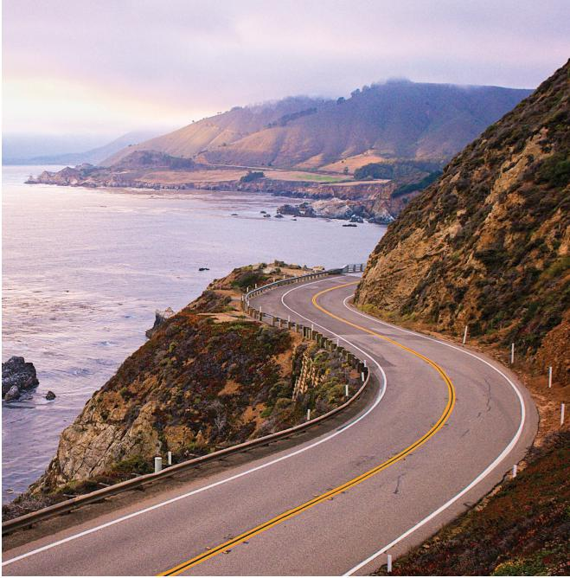
Highway 1
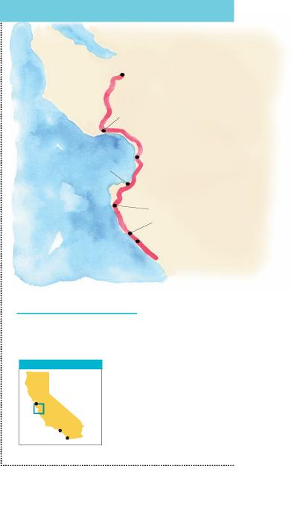
SAN JOSE TO BIG SUR
SAN JOSE
Steamer Lane
Monterey Bay Aquarium
Phil’s Fish Market
MONTEREY
Tickle Pink Inn
Pacific
Andrew Molera State Park
Ocean Post BIG SUR
Ranch
Inn
WORTH A DETOUR
Sun, wind, wine: Near Carmel Valley, more than 40 Santa Lucia Highlands wineries
pour stunning Pinot Noir and Syrah.
17-Mile Drive: Pacific Grove’s most famous road passes coastal overlooks and the golf links at Pebble Beach.
AREA OF DETAIL
San
iFrancisco
Los Angeles
San Diego
PROJOCKPHOTO/GETTY IMAGES
Push south on Highway 1 to Moss Landing. Pull over for seafood cioppino and grilled artichokes at Phil’s Fish Market, then watch for impossibly cute sea otters floating in the calm harbor waters.
Your next stop is Monterey, where you’ll need a full day at the Monterey Bay Aquarium. More than 200 galleries and exhibits showcase the wonders of the Pacific, including a three-story, glass-enclosed kelp forest and a mesmerizing jellyfish tank. Walk from the aquarium to Cannery Row’s cafés, wine-tasting rooms, art galleries, and sweet shops, and say hello to the sea lions at Fisherman’s Wharf.
Keep an eye on the time— you want to arrive at Carmel’s Tickle Pink Inn for wine and cheese hour and a glowing Pacific sunset. The next morning, head into downtown Carmel to browse shops and galleries in whitewashed bungalows fronted by cobblestone courtyards.
At midday, cross the graceful
Bixby Bridge to enter Big Sur. As you glide along Highway 1’s precipitous curves, take advantage of every pullout to scan the Pacific. (Make your stops low-impact and safe: Don’t block traffic or trample precious natural resources.)
Coastal views from your car are divine, but they’re even better when you get out and walk. At Andrew Molera State Park, trek a mile to driftwood-laden Molera Beach. At Pfeiffer Big Sur State Park, hike the Valley View Trail to an overlook of Point Sur and the Big Sur River Valley. Between all this walking, stop at the world-renowned Nepenthe for one of their Famous Ambrosiaburgers with a bird’s-eye ocean view. For maximum drama, stop at Julia Pfeiffer Burns State Park to watch the 80-foot McWay Falls plunge off a cliff.
There’s much more to dis-cover—top-notch restaurants, glorious beaches—so stay for a night or two at Post Ranch Inn, Ventana Big Sur, or Deetjen’s. If you’d rather sleep in your RV or tent, make sure you have reservations in advance—Big Sur is incredibly, deservedly popular.

34 | VISITCALIFORNIA.COM

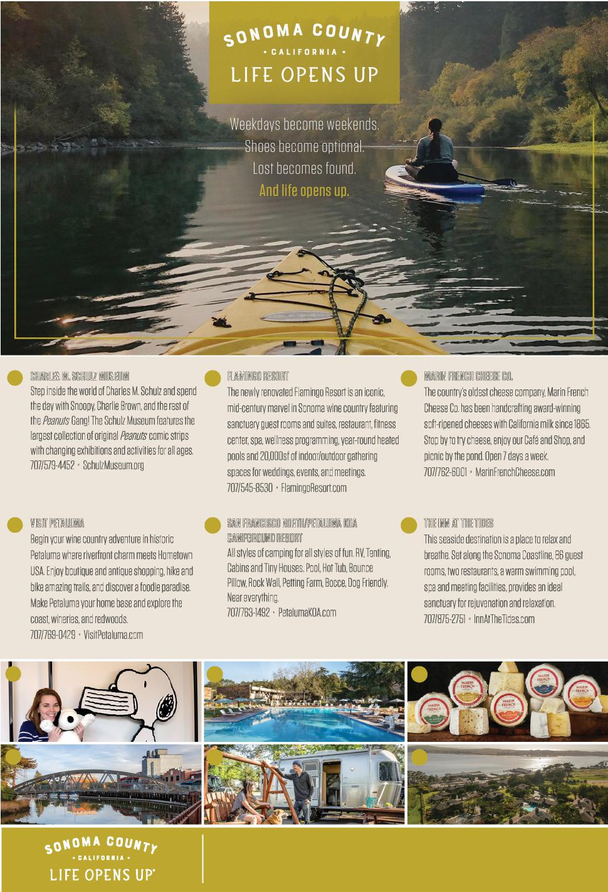
1
CHARLES .M. SCHULZ MUSEUM
Step iiinside the word of Chares M Schuz and spend the day iwith Snoopy, Chariie B,rown and the rest of the Peanuts Gang! The Schuz Museum features the
argest coeciion of iiorigina Peanuts icomic s1irips
iwith ichanging iiiexhibitions and iiiactivities for a ages
707/59-4452 • SchuzMuseum.org
4
1
2
5
3
6
2 FLAMIngo RESoRT
he newy renovated ilamingo Resort iis an iiiconic11,
imid1century marve iin Sonoma iwine country featuriing
sanctuary guest rooms and isuites, restaurant, ifitness
center spa, welness iprogramming yearround heated
Ipoos and 20000sf of iindoor/outdoor gatihering
spaces for iweddings, events, and imeetings
1
707/5458530 • iamingoResor.tcom
3 MARIn FREnCH CHEESE .Co.
he country’s odest cheese company, Mariin re nch Cheese Co. has been hanindcraftig award-inninwiig softiripened cheeses iwith Caiiifornia imik isince 865 Stop by to try cheese, enjoy our Café and Shop and iipicnic by the pond Open 7 days a week
_07/76216001 • iMarin1 renchCheesecom
4 VISIT PETALUMA
iBegin your iwine country adventure iin iihistoric
Petauma where iriverrnfot charm meets ometown
USA Enjoy iboutique and iantique ishopping, ihike and
bke amazng tras, and dscover a foode paradse Make Petauma yo ur home base and expore the coast, iiwineries, and redwoods
707/7690429 • iiVisitPetauma.com
5 SAn FRAnCISCo noRTH/PETALUMA KoA CAMPgRoUnd RESoRT
A styes of icamping for a styles of fun. RV, ientin,g
I_iCabins and iiny Houses Poo Hot Tub Bounce Pow Rock Wa Pettiing arm B,occe Dog rendy Near everi.ything
707/76311492 • PetaumaKOAcom
6 THE Inn AT THE TIdES
ihis iseaside iidestination iis a pace to reax and
br.eathe Set aong the Sonoma Coastiin,e 86 ⁻guest rooms two restaurants a warm iiswimming poo
spa and imeeting ifaciiiities iprovides an iidea
sanctuary for rejuvenatiion and reaxatiion
I
707/87512751 • nnAtTheiidescom
Isn’t it about time for a road trip to Sonoma County? Come explore our stunning natural landscape and discover unique experiences designed to renew, revive and restore. soNoMAcouNTy.coM

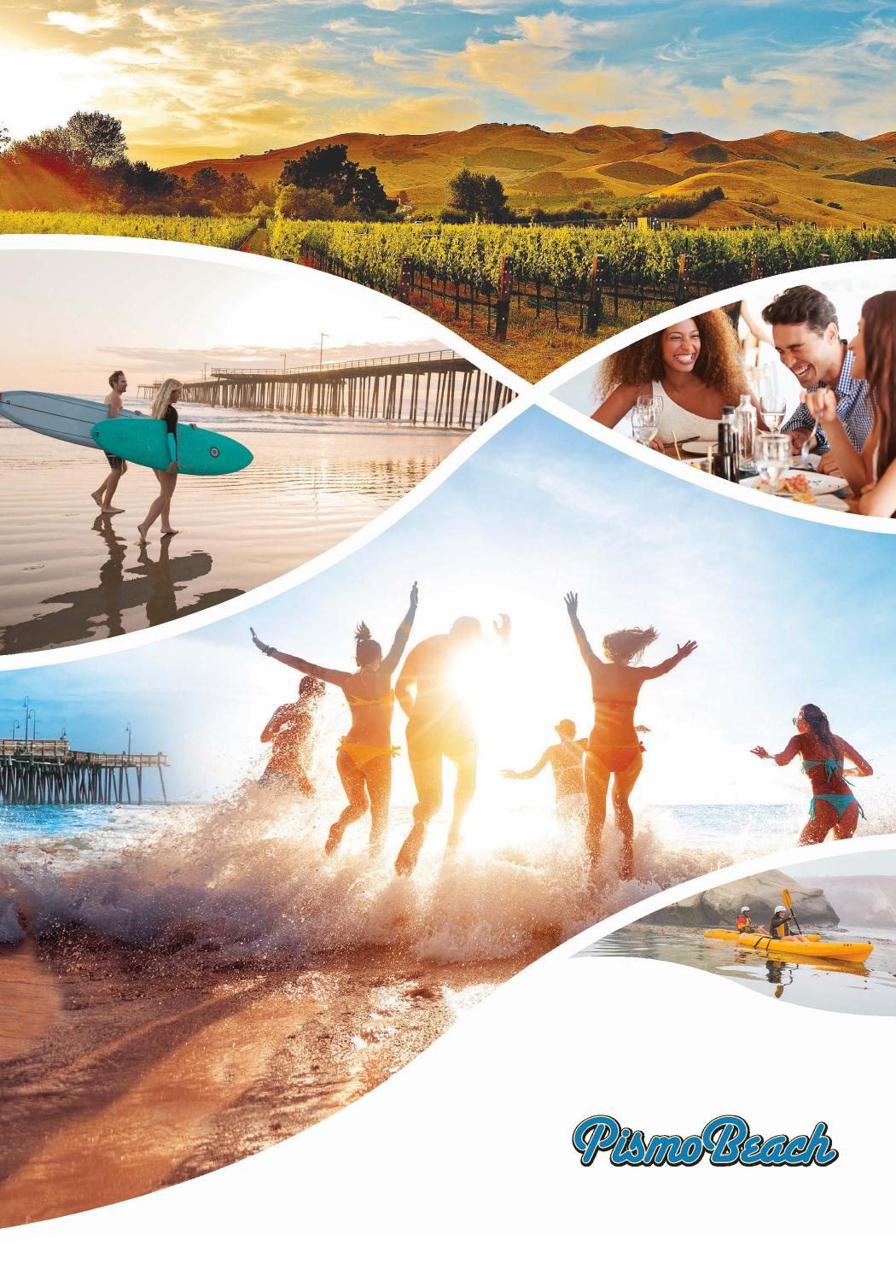
Explore. Exhale.
Experience.
#MyPismoBeach
Pismo Beach is located half way between
Los Angeles and the Bay Area and is famous for its miles of
beautiful white sand beaches, great accommodations and a rich
wine region, only minutes away. Come visit Pismo Beach and try surfing,
kayaking, exploring the dunes and
our wonderful dining opportunities.
ExperiencePismoBeach.com

Free Information  USE THIS HANDY RESOURCE TO RECEIVE FREE INFORMATION FROM THE ADVERTISERS LISTED HERE. THE NUMBER TO THE LEFT OF EACH ADVERTISER CORRESPONDS TO THE ATTACHED TEAR-OUT CARD. | BY MAIL  - Circle your choices on the tear-out card.  - Write in your name and address.  - Tear out the postage-paid card and mail.

1 Alpine County Chamber &
Visitor’s Center
2 Amador Wine Country
3 Big Bear Visitors Bureau
4 Bishop Area Chamber of Commerce & Visitors Bureau
5 Cabrillo Inn at the Beach
6 California Welcome Center Gilroy
7 Castello di Amorosa
8 Central Coast Tourism Council
9 Charles M. Schulz Museum
10 City of San Luis Obispo
11 Choice Hotels
12 County of Lake
13 Discover Buellton
14 Don’t Move Firewood
15 Explore Butte County
16 Fairfield - Gateway to Napa Valley
17 Flamingo Conference Resort & Spa
18 Harrah’s Northern California
19 Heritage Valley Tourism Bureau
20 Hilton Hotels Corporation
21 Hilton Santa Monica
22 Jackson Rancheria Casino Resort
23 Jelly Belly Visitors Center
24 Lake Piru
25 Long Beach Area Convention & Visitors Bureau
26 Majestic Mountain Loop
27 Marin Convention & Visitors Bureau
28 Marin French Cheese Company
29 Mendocino Coast Botanical Gardens
30 Monterey County Convention & Visitors Bureau
31 Monterey Touring Vehicles
32 Mono County Tourism Commission
33 North of Ordinary
34 Palms Springs Aerial Tramway
35 Petaluma Visitors Center
36 Pier 39
37 Pismo Beach
38 San Diego Zoo & San Diego Zoo Safari Park
39 San Francisco North/Petaluma KOA Campground Resort
40 Santa Maria Valley Convention & Visitor’s Bureau
41 Sausalito Chamber of Commerce
42 Shasta Cascade Wonderland Association
43 Skunk Train
44 Sonoma County Tourism
45 Tenaya Lodge at Yosemite
46 The Inn at the Tides
47 The Redwoods in Yosemite
48 Trees of Mystery
49 Tuolumne County Visitors Bureau
50 Ventura County Coast
51 Ventura Harbor Village
52 Visit Amador
53 Visit Calistoga
54 Visit Carlsbad
55 Visit Lompoc
56 Visit Huntington Beach - Surf City USA
57 Visit Morgan Hill
58 Visit Placer
59 Visit San Jose
60 Visit Santa Cruz
61 Visit the Santa Ynez Valley
62 Visit Ventura
63 Visit Visalia
64 Visit Yosemite | Madera County
65 Visit Yuba Sutter
66 Warner Bros. Studio Tour
67 Yosemite Mariposa County
Tourism Bureau
68 Yosemite’s Scenic Wonders

Information for this card will not be provided after March 31, 2022
VISITCALIFORNIA.COM | 37
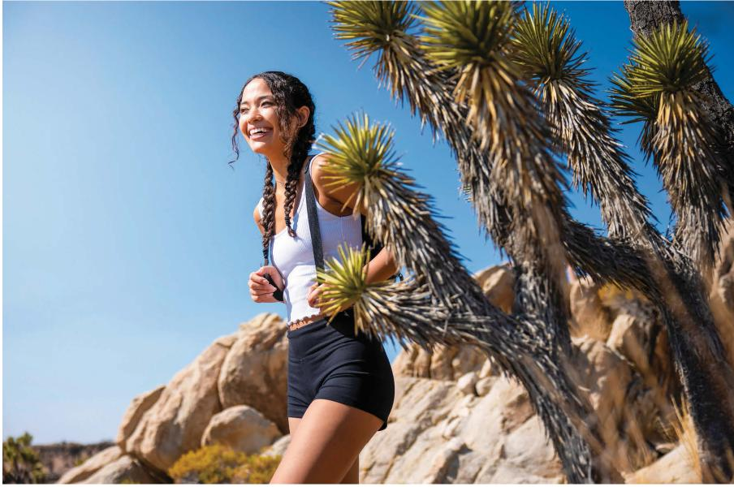
Mojave National
Preserve

ROAD TRIPS 2021

Gateway Essentials:
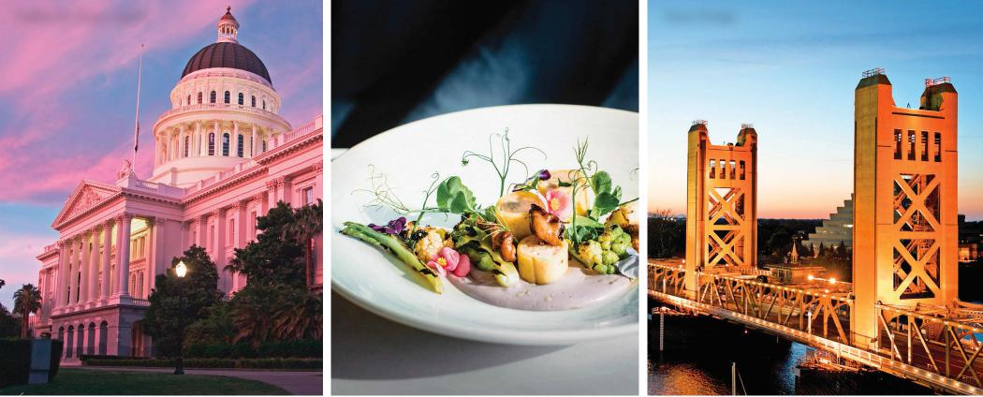
California State Capitol Localis Tower Bridge
Sacramento & Beyond

urrounded by farmland, Sacramento blends both town and country—it has the vitality of California’s bigger cities, but on an intimate scale. The capital city’s history and politics blend in with convivial breweries, a burgeoning arts movement, and sophisticated restaurants. Eating matters here: Since Sacramento is the hub of California’s agricultural region, farm-to-fork isn’t just a slogan. Year-round farmers markets attract a food-forward crowd, and restaurants like Ella Dining Room & Bar, Localis, Mulvaney’s B&L, and The Kitchen Restaurant elicit praise and draw visitors from around the country.
S
EATING MATTERS HERE:
SINCE SACRAMENTO IS THE HUB
OF CALIFORNIA’S AGRICULTURAL
REGION, FARM-TO-FORK
ISN’T JUST A SLOGAN.
Sacramento International Airport makes getting to the area a breeze. Its runways are just 10 miles from downtown, with easy freeway access from Interstate 5 or Highway 99.
To see echoes of the Gold Rush days, head to Old Sacramento. This riverfront corridor was the heart of commerce during the mid-1800s— historic buildings line its cobblestone streets and raised wooden sidewalks. Among an array of candy shops and saloons, you’ll find the Sacramento
History Museum filled with many Gold Rush-era artifacts, and the California State Railroad Museum’s lavishly restored 1860s locomotives. You can’t miss the 1927 Delta King Riverboat, moored along Old Town’s riverbanks, now a hotel with two restaurants. During its heyday, the 285-foot ship made hundreds of trips between San Francisco and Sacramento.
Get a bead on Sacramento’s street-art scene by wandering through revitalized Midtown to see eye-catching murals splashed across old and new buildings. Visit contemporary galleries like the Verge Center for the Arts, Elliott Fouts Gallery, or Groundswell. Midtown is an epicenter for all that’s hip and trendy, from third-wave coffee to Korean-fusion tacos. High-
minded eateries and cool shops are tucked into old Victorian mansions and Craftsman bungalows.
Turn on your right brain at the steel-and-concrete Crocker Art Museum, which boasts more than 15,000 works from around the globe. Not far away is Sacramento’s impressive Capitol building, an elegant 1869 structure with an imposing 128-foot-high dome and garden of 1,200 rose bushes.
If you have kids in tow, rent bikes and pedal the American River Bike Trail, which spans 32 miles from Old Sacramento all the way to Folsom Lake. For the youngest tykes, a trip to Fairytale Town is a must—play structures mimic settings from nursery rhymes and fables, and a mini-farm has friendly goats, pigs, and sheep.
FROM LEFT: ALWAYS WANDERLUST/SHUTTERS TOCK; SORAYA MAT OS; JMOOR17/GETTY IMAGES. OPPOSITE PAGE: VISIT CALIFORNIA

38 | VISITCALIFORNIA.COM

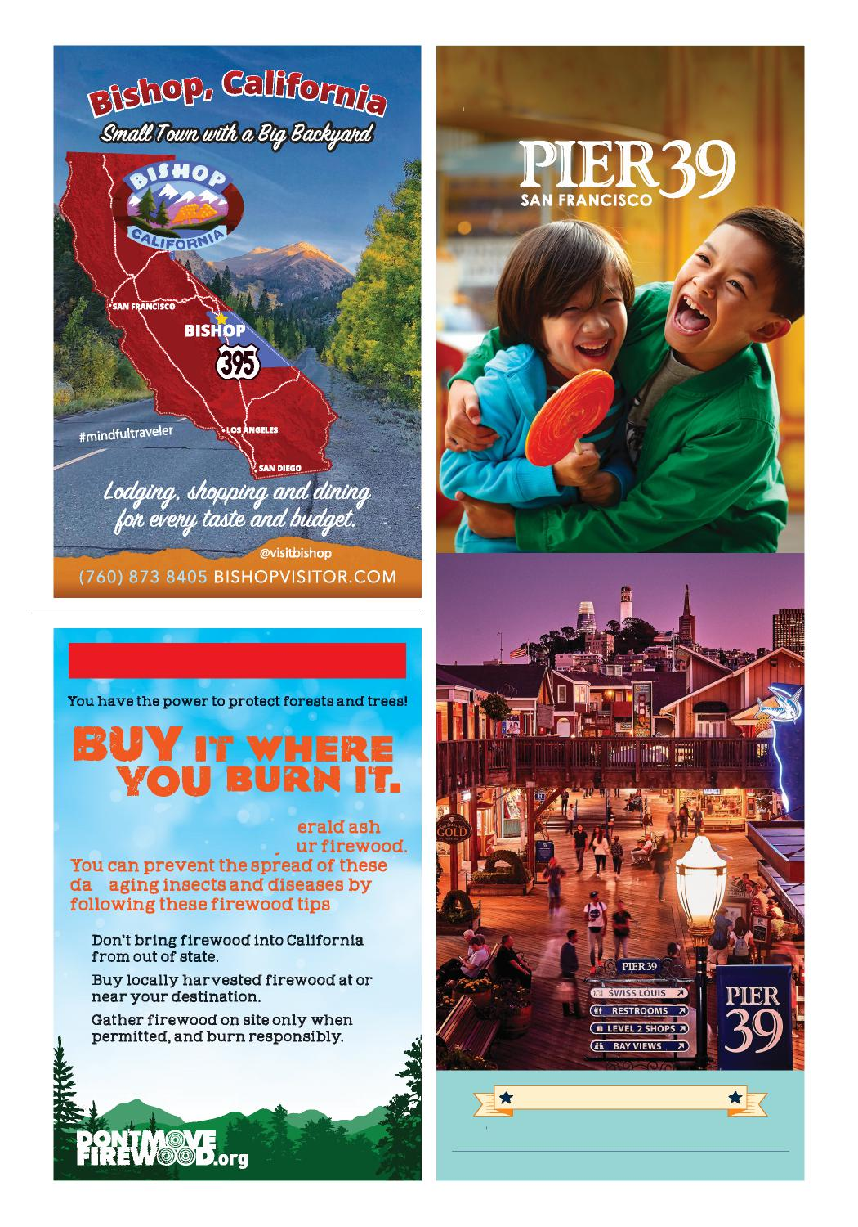
Get together at
FIREWOOD ALERT!
Pests like the in asi e em
borer can hitchhike in o
m
:
u u
u
PARKING SPECIALS AVAILABLE @ PIER39.COM
Learn more: firewood.ca.gov
THE EMBARCADERO @ BEACH STREET
See Current Visiting Guidelines at Pier39.com

et the day started with an espresso from Temple Coffee Roasters in Sacramento. Then follow Interstate 80 north to Auburn to step back in time at the Gold Rush Museum and sip award-winning IPAs at Knee Deep Brewing.
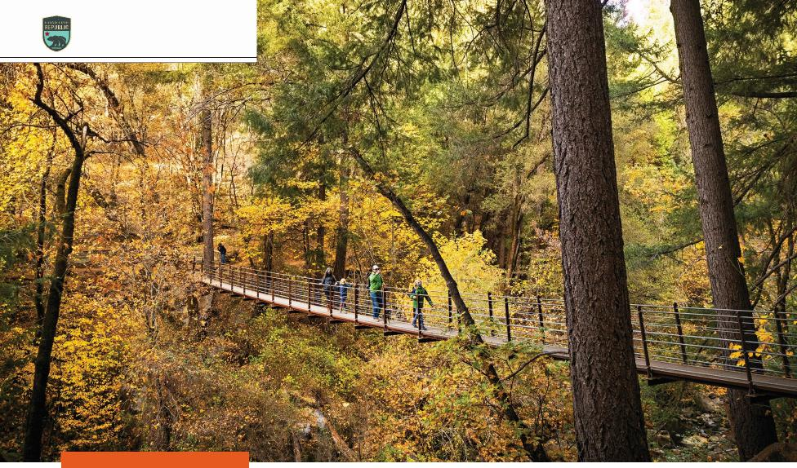
ROAD TRIPS 2021
Deer Creek Tribute Trail,
Nevada City
DISTANCE: 257 MILES • DAYS: 2–3
Foothills to Tahoe
DISCOVER ENCHANTING GOLD RUSH TOWNS AND NORTH AMERICA’S LARGEST ALPINE LAKE
G
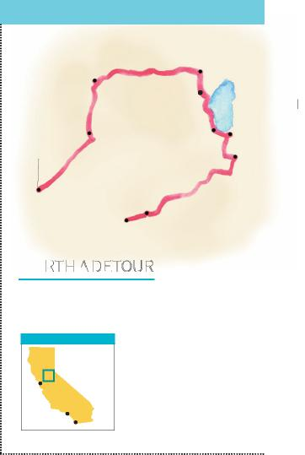
Heavenly
Mountain
Resort
Temple
Coffee
Roasters
Wylder Hotel
AREA OF DETAIL
Lakeside hike: At Emerald Bay State Park, the 7-mile Rubicon Trail travels along Tahoe’s
western lakeshore.
Grape legacy: See antique wine presses at Plymouth’s Sobon Estate, one of California’s earliest wineries (1846).
SACRAMENTO TO SUTTER CREEK
Knee Deep Brewing
The Willo Steakhouse
Word After Word Books
LAKE TAHOE
Olympic Valley
SACRAMENTO
Black
Chasm
Cavern
SUTTER CREEK
WORTH A DETOUR
San Francisco
Los Angeles
San Diego
MAX WHITTAKER
Highway 49 passes through Nevada City, where 19th-century buildings house tasting rooms, shops, and eateries. Shop for joy-sparking gifts at J. J. Jackson’s or walk the Tribute Trail along Deer Creek. Eat a hearty meal at The Willo Steakhouse, a no-frills watering hole operating since 1969.
Highway 20 travels through a forest of pines to cowboy-chic Truckee. Spend the night at Cedar House Sport Hotel, then get up early for breakfast at Squeeze Inn and a hike to Castle Peak. Stroll downtown for handcrafted finds at Riverside Studios and then check out the literary scene at Word After Word Books.
Follow Highway 89 south as it meanders along the Truckee River and swings past Olympic
Valley. Pedal along the Truckee River Bike Path or float downstream (you can rent rafts in Tahoe City).
Highway 89 takes you to Lake Tahoe’s northwest shore, where the vistas stretch across the lake. Snap a photo to capture it and then go on a short jaunt to glistening Eagle Falls. Beyond the waterfall, the granite peaks of Desolation Wilderness beckon. Your gaze will wander to the scenery, but stay focused on the road, which skirts high above Tahoe’s crystal blue depths.
Before entering South Lake Tahoe, stop for a dip at Pope Beach, then detour five miles east on U.S. 50 for a gondola ride to the top of Heavenly Ski Resort. Grab a veggie sandwich at Sprouts, and rent a stand-up paddleboard at Regan Beach for a few laps along the shoreline.
Leaving South Lake Tahoe, ascend Luther Pass through aspen groves and head into Hope Valley. Stay the night in a yurt at Wylder Hotel or camp under the stars. In the morning, ascend to 8,652-foot Carson Pass to see summer wildflowers.
Your route winds past Kirkwood Ski Resort and Silver Lake into the vineyard-dotted northern Gold Country. Look for ghosts at the historic St. George Hotel in Volcano, and tour Black Chasm Cavern’s limestone treasures. Make Sutter Creek your base for a night or two so you can end this trip tasting bold red wines at Shenandoah Vineyards.

40 | VISITCALIFORNIA.COM

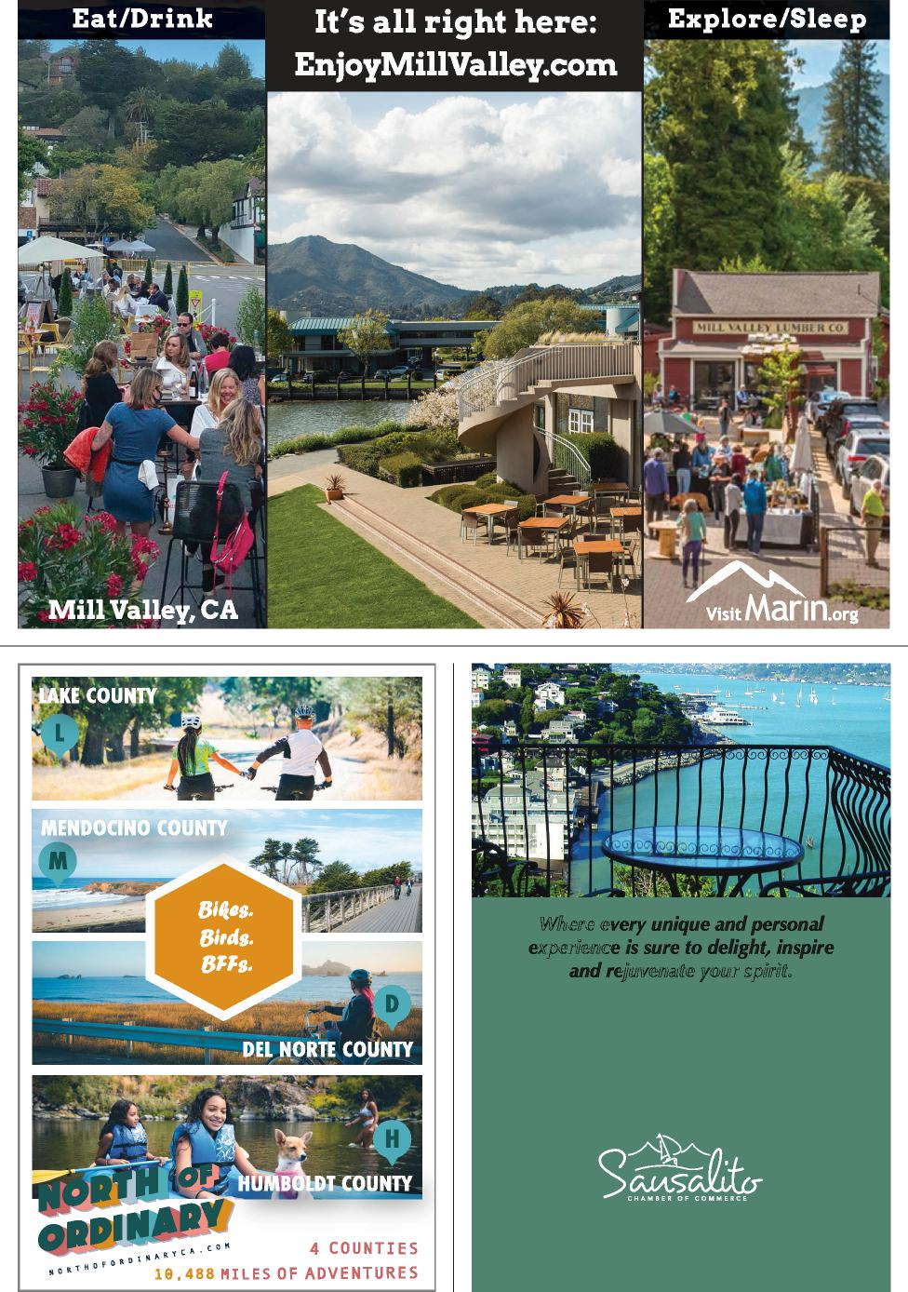
W
x c
j .
Just across the Golden Gate, sits the world-renowned waterfront
community of Sausalito with stunning views, small-town charm,
world-class dining and a vibrant artist’s community. Visitors
enjoy outdoor recreation including hiking, biking, water
recreation and strolls along the bay. Sausalito also offers
unique boutique shops and an eclectic Visitors Center, featuring
artists and products from Sausalito and Marin County.
visitsausalito.org sausalito.org

egin your adventure in Sacramento by filling up on grilled cheese eggs Benedict at Bacon & Butter, then head north on I-5. In two hours, brake in Corning to taste jalapeño-stuffed olives at Olive Pit and pick up dipping oils at Corning Olive Oil Company.
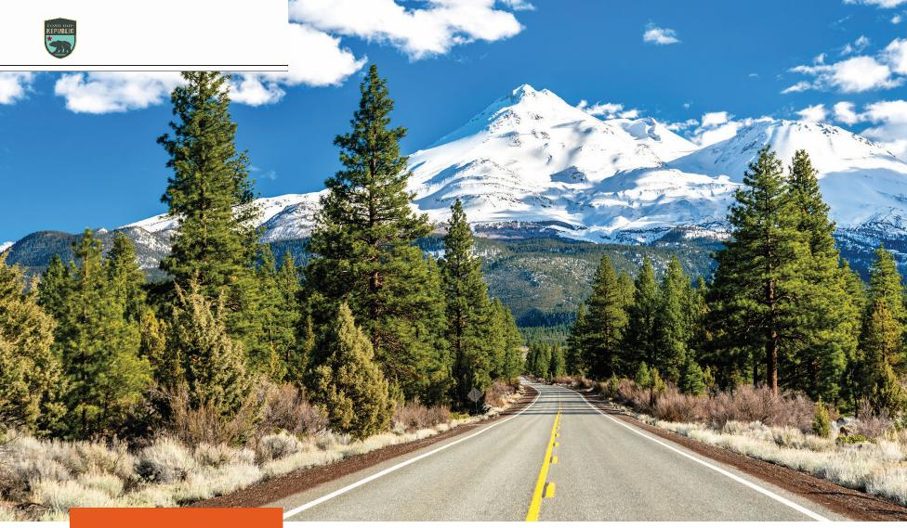
ROAD TRIPS 2021
Mount Shasta
DISTANCE: 560 MILES • DAYS: 4–5
Northern Grandeur Adventure
RAMBLE PAST A CINEMATIC LANDSCAPE OF NATURAL WONDERS IN “UPSTATE CALIFORNIA”
SACRAMENTO TO LASSEN
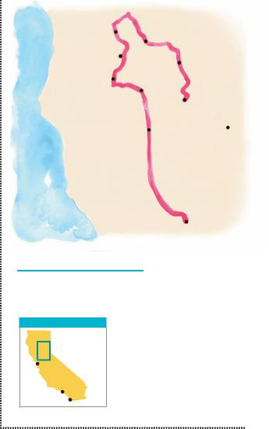
AREA OF DETAIL
Dream of trains: Spend the night in a cozy caboose or vintage cabin at Railroad Park
Resort in Dunsmuir. Good old days: Near Etna, stop at the 1854 Callahan Emporium for a cold beverage from its antique icebox.
Etna
Brewing
Company MT. SHASTA CITY
Coffee Creek Ranch
McArthur-Burney Falls
Joss House
Bumpass Hell
Sundial Bridge
Olive Pit
LASSEN
VOLCANIC
NATIONAL
PARK
Bacon & Butter
SACRAMENTO
WORTH A DETOUR
Mt. Shasta
San Francisco
Los Angeles
San Diego
Pacific Ocean
B
LEONID ANDRONOV/GETTY IMAGES
Your next stop is Redding, home of Turtle Bay Exploration Park’s eco-museum and arboretum. Get up-close with a porcupine and walk into an aviary filled with colorful Australian lorikeets. Outside, traipse across the 710-foot-long Sundial Bridge, one of the world’s largest functioning sundials.
The next day, head west on Highway 299 to history-rich Weaverville. Tour the 1874 Joss House, a temple built by Chinese miners who came to the Trinity River region in search of gold. The temple’s artifacts include wrought-iron weapons and a 3,000-year-old altar brought here from China.
Hop on twisty Highway 3 and cruise north to Coffee Creek,
a gateway to the Trinity Alps Wilderness. Stay at off-the-grid Coffee Creek Ranch and ride their trusty horses to alpine lakes and glacially carved peaks.
Winding northward, you’ll reach Etna, population 700. This tiny town is a major stopover for hikers on the 2,650-mile Pacific Crest Trail, so Etna Brewing Company and Trailhead Pizza bustle in summertime.
Beyond Etna, Highway 3 meets up with I-5 at Yreka. Turn south toward Mount Shasta’s volcanic cone, crowned with snow for most of the year. A detour for hikers: From Mt. Shasta City, follow Everitt Memorial Highway up the slopes, then hike to Gray Butte for a view of the 14,179-foot summit.
Backtrack down the hill and then follow Highway 89 into McCloud. Admire three powerful waterfalls on the McCloud River before heading to the 129-foot falls at McArthur-Burney Falls Memorial State Park.
Your final stop is Lassen Volcanic National Park,
revered for its out-of-this-world landscape. Hike to the top of Lassen Peak, kayak on Manza-nita Lake, trek to Kings Creek Falls, or swim in Juniper Lake. Don’t miss the hydrothermal spectacle at Bumpass Hell—16 acres of boiling springs and bubbling mud pots.

42 | VISITCALIFORNIA.COM

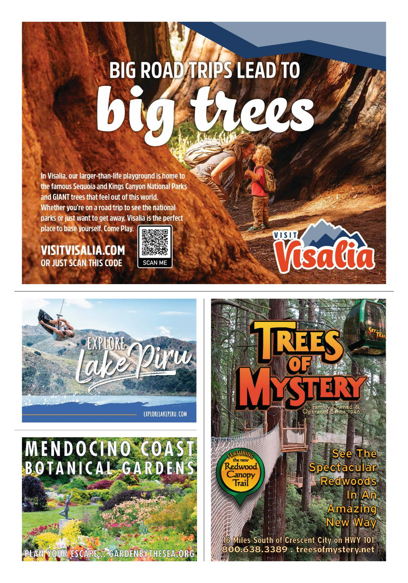
TM
Family Owned & Operated Since 1946

eave Sacramento via the Tower Bridge—a 1935 art deco beauty painted metallic gold—and zoom west to the farming town of Winters. Stock up on local fruit, preserves, and nuts from Winters Fruit Tree and cookies from Lester Farms Bakery.
ROAD TRIPS 2021
DISTANCE: 335 MILES • DAYS: 3–4
Wine to
Waterfalls
AN EPIC WINE-TASTING EXPEDITION LEADS TO YOSEMITE’S WONDERLAND
L
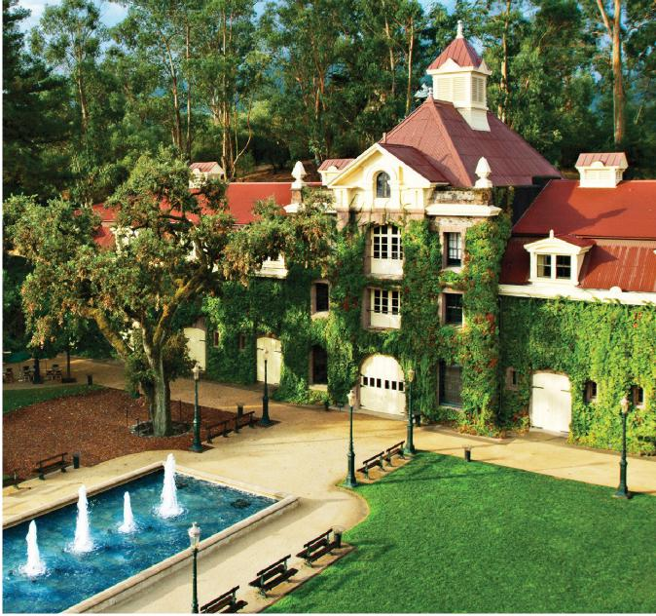
Inglenook winery
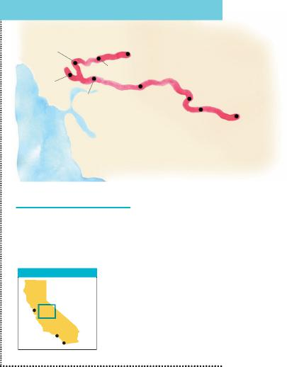
SACRAMENTO TO YOSEMITE
Mumm Napa
SACRAMENTO
Tower Bridge
Lester Farms Bakery
Sonoma Plaza
Pacific Ocean
Jelly Belly LODI
Factory Half
Dome
Groveland Hotel
Fallon House Theatre
YOSEMITE
NATIONAL
PARK
WORTH A DETOUR
Big vista: Ascend to 11,053 feet on the Panorama Gondola in Mammoth Lakes, then have lunch at Eleven53 Café.
Hidden gem: Add in a trip to Lake County to taste around the Red Hills AVA, an up-and-coming appellation with many high-value wineries.
AREA OF DETAIL
San Francisco
Los Angeles
San Diego
COURTESY INGLENOOK WINERY
Put on your driving gloves for Highway 128’s ascent over the Vaca Mountains and down into the fertile Napa Valley, home to more than 400 wineries. Start with bubbles: Head to Rutherford’s Mumm Napa to taste some delicious sparkling wines. Next up, Cabernet Sauvignon: Visit the fabulous chateau and sprawling courtyard at Inglenook, owned by filmmaker Francis Ford Coppola, and then marvel at the artwork at Robert Mondavi Winery in Oakville.
Don’t miss Napa’s Michelin-starred dining scene. In Yountville, try for a spot at Thomas Keller’s Bouchon Bistro or Ad Hoc, or head to Napa to stroll Oxbow Public Market and sample your way through 20-plus vendors—from Hog Island oysters to Gott’s cheeseburgers.
Pace yourself, though, because you’re headed to Sonoma Valley, home to 17 distinct AVAs. Take Highway 12 west to Sonoma’s alluring plaza, then park and walk among the historic buildings, inviting eateries, and shops. Head north to quaint Glen Ellen for more wine tasting: Talisman and Schermeister for Pinot Noir, Eric Ross for Syrah, Laurel Glen for Cabernet Sauvignon.
As you leave Sonoma, let Highway 12 lead you to a different indulgence. To the east in Fairfield, pause at the Jelly Belly Factory for a tasting of the irresistible confections.
Continue east past the fertile California Delta to Lodi, where 80 wineries beckon. Love big reds? Taste old-vine Zinfandels inside a 50,000-gallon redwood tank—the tasting room at Oak Ridge—or at Jeremy Wine Company or Harney Lane. Another hour and you’re in Murphys, where you can sip robust Barberas and Zinfandels at 20 walking-distance tasting rooms.
Backtrack a few miles to Parrotts Ferry Road, then wind south. Today the gold in Gold Country is red and pours from 750ml bottles, but Columbia State Historic Park preserves the legacy of the fortune-seeking 1850s. Time-travel back to the gold-mining days in old-timey saloons or catch a show at the Fallon House Theatre.
Head up Highway 120 on Priest Grade’s winding curves to Groveland, then rest up at the Groveland Hotel. Take an open-air tram tour around the Yosemite Valley floor, then hike
to experience 594-foot Nevada Fall. Eat lunch in The Ahwahnee hotel’s elegant dining room, or cool off at Cathedral Beach with a perfectly framed view of El Capitan. As the day wears on, find a spot near Sentinel Bridge to watch Half Dome turn orange from the setting sun’s glow.

44 | VISITCALIFORNIA.COM

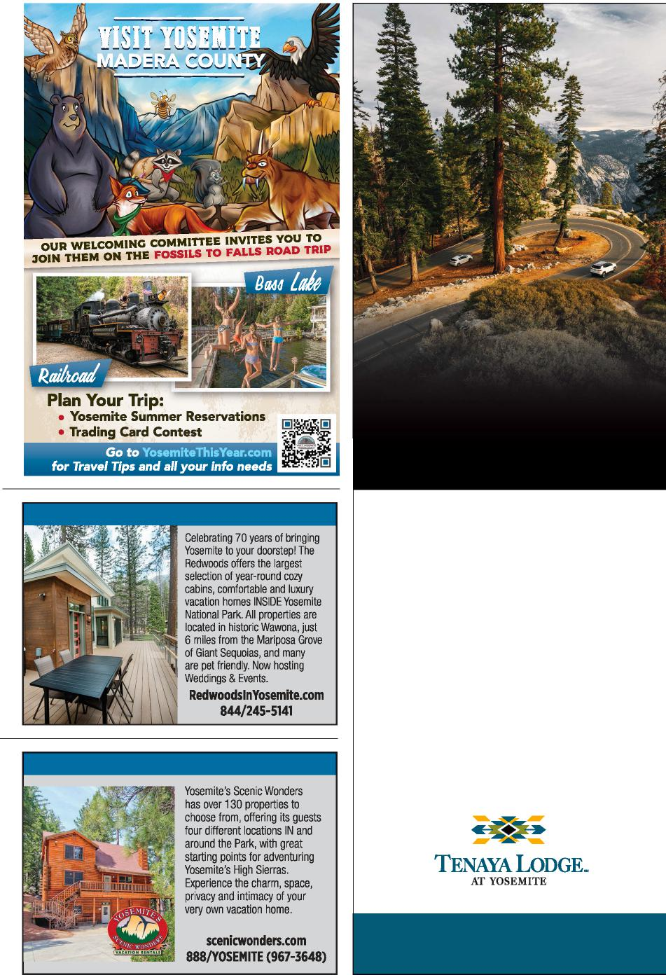
THE DESTINATION
IS A THRILL.
SO IS THE DRIVE.
THE REDWOODS | IN YOSEMITE
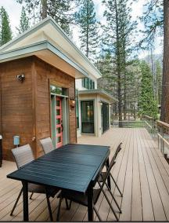 | 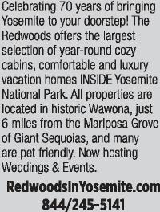
YOSEMITE’S SCENIC WONDERS
There’s a wonderful freedom to the open road—especially when it leads to an epic place like the Yosemite region. Whether you’re coming to Tenaya Lodge at Yosemite by vehicle or motorcycle, it’s well worth the journey. At our resort or Explorer Cabins, you’re just two miles from the wonders of Yosemite National Park.
Today’s the day to kick the tires on your Yosemite road trip.
TENAYALODGE.COM | 888.514.2167

How to Take Your
Dog Along for the Ride
ROAD TRIPS 2021
Santa Cruz
IN CALIFORNIA, ALL ROAD TRIP DREAMS ARE
WELCOME—INCLUDING DOGGIE DREAMS

lanning a road trip this year may mean adding one member to your inner circle: the family dog. Happily, California makes for a great place for fur babies to explore and play.
P
“California is by far the most dog-friendly state in the coun-try—and most likely, the world,” says Dave Kendrick of DogTrek-ker, a website and app that showcases pet-friendly hotels, restaurants, and things to do in the Golden State. “California offers 100-plus great dog-friendly activities, from house-boating in the Shasta Cascade to riding Mendocino’s Big River on redwood outrigger canoes or
eating with your best friend in the farm-to-fork capital.”
In some ways, the pandemic has made dog travel easier than ever. “California is a great destination to visit right now,” says Erin Ballinger, destinations editor of BringFido.com, a site that covers dog-friendly travel. She sees travelers planning longer trips these days, including classic, play-it-by-ear road trips. “There are so many safe, dog-friendly destinations—like beaches, state and national parks, hiking trails, and restaurants with large patios.”
Those patios are making it easier for travelers like Bobby and Alli Talley, whose blog,
Traveling Newlyweds, includes tips on road trips with their bernedoodle Sally. “Restaurants that didn’t used to have outdoor dining options, and didn’t welcome dogs, now do,” says Bobby. “Before COVID-19, we were always sitting outside with our dog. But now it’s normal.” Here are some tips to help with your planning:
Head to the beach.
Dogs and sand go together like surfers and waves. Along the pup-friendly Central Coast, dog-friendly beaches include Monterey County’s Carmel Beach and Asilomar State Beach, as well as Surfer’s Point
BRUSSELS IMAGES/GETTY IMAGES

46 | VISITCALIFORNIA.COM

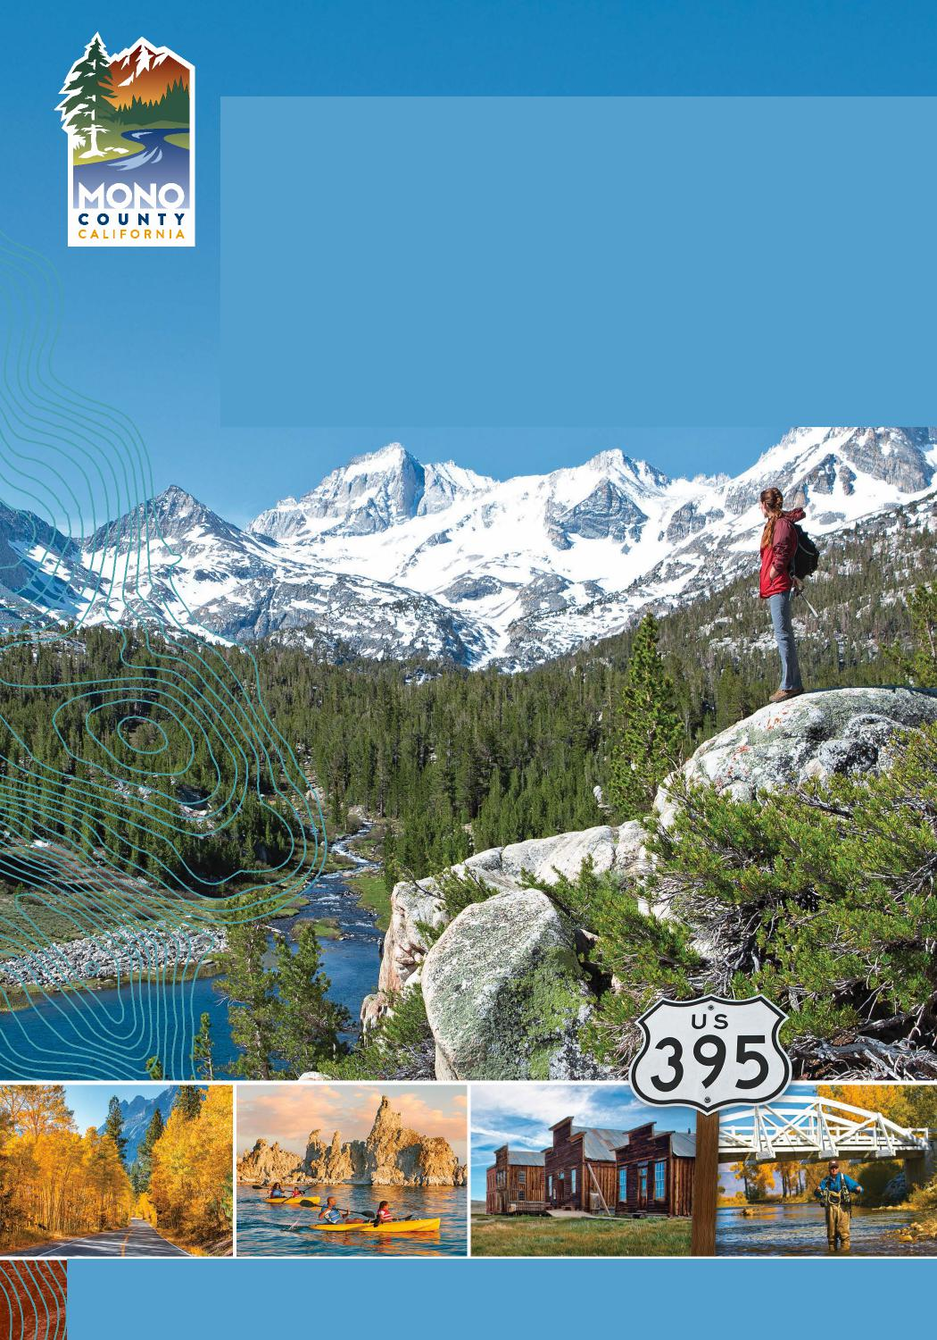
CALIFORNIA'S
GREAT BEYOND
Beyond expectations, Scenic Byway US Highway 395 in California's Eastern Sierra is home to Yosemite's dramatic east entrance, Mono Lake's mystical tufas, and Bodie —California's official ghost town—and so much more. With mountains of photo ops around every bend, the road less traveled is the road best traveled.
With the great beyond, comes great responsibility. Please help us take care of this special part of the world so it is here for all of us to enjoy. Forever.

FOR A FREE MONO COUNTY VISITOR GUIDE: 800-845-7922

and Harbor Cove in Ventura County. In Los Angeles County, check out Rosie’s Beach in Long Beach, or head to Orange County for the sandy playground of Huntington Dog Beach. In San Diego, pups love Del Mar Dog Beach and the stretch of Ocean Beach known as “the original dog beach.” The Lake Tahoe area has its own dog-friendly beaches, including South Lake Tahoe’s Kiva Beach and North Lake Tahoe’s Pebble Beach.
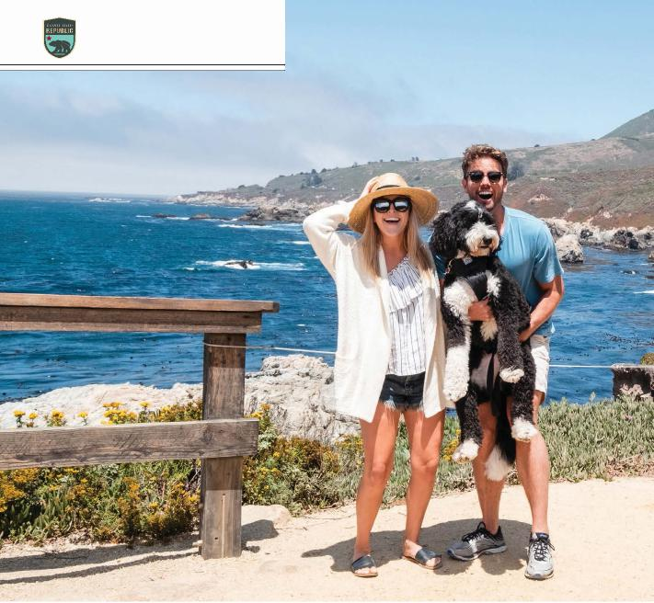
ROAD TRIPS 2021
Bobby and Alli Talley with their bernedoodle, Sally
Think outside of the dog park.
A recent survey from DogTrek-ker showed that cultural and historical destinations are on the upswing for traveling dogs. California’s North Coast region—which encompasses Mendocino, Lake, Humboldt and Del Norte counties—fea-tures dozens of dog-friendly things to do such as outdoor wine tastings, the Trees of Mystery park in Klamath, and even the historic locomotive excursion Skunk Train. At Sonoma County’s Mutt Lynch Winery, your pup can enjoy free dog-treat flights while you sip a
Chardonnay or Pinot Noir. Ventura County is so dog-friendly that pooches can browse at the Camarillo Premium Outlets. In Concord, dogs are welcome at taprooms such as The Hop Grenade, Epidemic Ales, and Lazy Dog—where a “pup menu” includes a hamburger patty bowl with brown rice and veggies.
Know the rules at state and national parks.
Most national parks allow pets in campgrounds or on paved trails, but typically not on
hiking trails. Many of the 280 California state parks, however, do allow dogs on trails, including Mendocino Headlands State Park, Monterey State Historic Park, and the grounds of Sacra-mento’s California State Capitol.
Check for fees and breed restrictions when choosing a hotel.
Some charge a onetime fee, a per-night fee, or perhaps no fee at all. At the Beverly Hills Hotel, all sizes are welcome for just $35 a night, and dogs are greeted with bowls, plush beds, and personalized bone-shaped cookies made by the hotel bak
ers. Some brands are known for welcoming big dogs, too—such as Kimpton, La Quinta, Motel 6, and Loews. “You can almost always find a La Quinta, even alongside the road,” says Alli. “They’re super dog friendly, and there’s no dog fee, so we love that.” The boutique-chain Kimp-ton also charges no fee, and the Talleys love their dog amenities, including bowls and treats. “They’ll write your dog’s name on a welcome sign outside, and they almost always have a happy hour in the evenings where dogs are invited.”
Look at the hotel’s map view before you book.
See if there are parks, cafes, or other necessities within walking distance. In Monterey, the city’s off-leash dog park is about a mile from both the dog-friendly Portola Hotel & Spa and top spots such as Fisherman’s Wharf and Cannery Row.
Don’t overpack.
The Traveling Newlyweds love their Kurgo doggie seatbelt tether for comfortably securing Sally on road trips. Otherwise they “just bring collapsible water bowls and snacks,” says Alli. “Anywhere in California, there will be a store where you can buy supplies as needed.”
Let your pup set
the tone.
You might find that planning a vacation around the dog ends up feeling pretty liberating. “Traveling with Sally actually forces us to walk more in destinations,” says Alli. “We’ll say, ‘Let’s find a restaurant that’s walking distance from the hotel,’ and we end up seeing more of the destination that way.” Bobby adds that Sally is the ultimate conversation starter. “When we’re in a hotel lobby or at a brewery outside, people want to know what kind of dog she is— or ask about dog-friendly travel. We make friends.”
COURTESY ALLI & BOBBY TALLEY/@TRAVELING_NEWLY WED S

48 | VISITCALIFORNIA.COM

Visit ChoiceHotels.com/California-Hotels or call 1-888-846-9378 to get our lowest price guaranteed.**
*Rate Restrictions: Valid only for Choice Privileges members (program enrollment is free). The reservation must be made on ChoiceHotels.com at participating hotels and must be made at least 7, 14, 21 or 30 days in advance, which will vary based on the hotel for which a reservation is being made. Subject to availability, the rate starts at 15% off Best Available Rate, is non-cancellable, non-changeable and non-refundable. Your credit card will be charged for the total reservation amount within 24-48 hours of booking. This rate has a seven (7) night maximum length of stay. Rooms at this discount are limited. Offer is not available to groups and cannot be combined with any other discount. Choice Hotels reserves the right to change or discontinue this offer at any time. Eligibility restricted to U.S. and Canadian residents. Members must book direct at ChoiceHotels.com/California-Hotels or call 1-888-846-9378. All Choice Hotels properties are independently owned and operated. **Guarantee applies to Third Party Website standard rates for a Choice single or double occupancy room that are at least 1% and $1.00 less than the Choice rate. Claims must be submitted within 24 hours of booking and 48+ hours prior to 6 PM check-in time the day of hotel arrival. Other terms also apply; see www.choicehotels.com/legal/best-rate-rules for full terms and conditions. ©2021 Choice Hotels International. All rights reserved.

What if you could
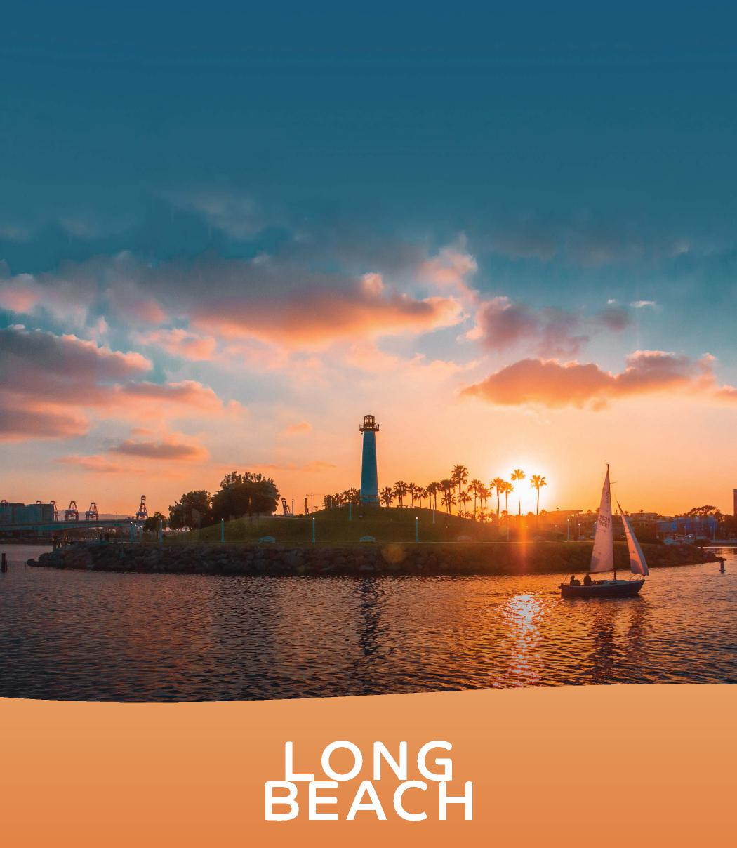
FLOAT THE DAY AWAY?
You can, in Long Beach — where the quintessential beach-chic vibe
is waiting for you. Go two-wheeling down the bike paths. Cruise on
a kayak, paddleboard or aquabike. Catch a Gondola ride. Explore
the underwater world at the Aquarium of the Pacific. Shop, sip and
grab a bite on the waterfront or in the eclectic neighborhoods.
The options are as limitless as the sun-drenched horizon.
FOR MORE IDEAS AND INSPIRATION
VisitLongBeach.com
CALIFORNIA

